|  |
| --- |
|  |

**FPT UNIVERSITY**

|  |  |
| --- | --- |
| Capstone Project Document | |
| **Hair Salon Booking** | |
| Group 2 - JS | |
| **Group members** | Nguyễn Lữ Đại Sơn – SE62579  Đoàn Văn Công – SE62449 |
| **Supervisor** | Lại Đức Hùng |
| **Ext. Supervisor** | N/A |
| **Project Code** | HSB |

**– Ho Chi Minh City, May 13th, 2019 –**

This page is intentionally left blank

**Table of Contents**

**Table of Contents** 3

List of Tables 6

List of Figures 9

A. Introduction 12

1. Project Information 12

2. Introduction 12

3. Current Situation 12

4. Problem Definition 13

5. Proposed Solution 13

5.1. Functions 13

5.2. Advantages and disadvantages 14

6. Functional Requirements 14

6.1. Mobile application and hair-salon website 14

6.2. Admin website 15

7. Role & Responsibility 16

B. Software Project Management Plan 17

1. Problem Definition 17

1.1. Name of this Capstone Project 17

1.2. Problem Abstract 17

1.3. Project Overview 17

2. Project Organization 21

2.1. Software Process Model 21

2.2. Roles and responsibilities 22

2.3. Tools and Techniques 23

3. Project Management Plan 24

3.1. Software development life cycle 24

3.2. Phase detail 25

3.3. All Meeting Minutes 28

4. Coding Convention 28

C. Software Requirement Specification 29

1. User Requirement Specification 29

1.1. Guest requirement 29

1.2. Customer requirement 29

1.3. Salon Manager requirement 30

1.4. Admin requirement 30

2. System Requirement Specification 30

2.1. External Interface Requirement 30

2.2. System Overview Use Case 32

2.3. List of use case 33

3. Software System Attribute 65

3.1. Usability 65

3.2. Reliability 65

3.3. Availability 65

3.4. Security 65

3.5. Maintainability 65

3.6. Portability 65

3.7. Performance 65

4. Conceptual Diagram 66

D. Software Design Description 68

1. Design Overview 68

2. System Architecture Design 69

2.1. Admin web application 70

2.2. Mobile application 70

3. Component Diagram 71

4. Detailed Description 73

4.1. Class Diagram 73

4.2. Class Diagram Explanation 76

4.3. Sequence diagram 83

4.4. Activity Diagram 92

5. Interface 98

5.1. Component Interface 98

5.2. User Interface Design 102

6. Database Design 122

6.1. Entity Relationship Diagram (ERD) 122

6.2. Data Dictionary 124

7. Algorithms 126

7.1. Find best salon 126

E. System implementation & Test 131

1. Introduction 131

1.1. Overview 131

1.2. Test Approach 131

2. Database Relationship Diagram 131

2.1. Physical Diagram 131

2.2. Data dictionary 133

3. Test Plan 133

3.1. Features to be tested 134

3.2. Features not to be tested 134

4. System Testing Test Case 134

4.1. Mobile app testing case: 134

4.2. Web app testing case 140

F. Software User’s Manual 144

1. Installation Guide 144

1.1. Setting up environment at server 144

1.2. Deployment at server side 146

1.3. Deploy web application on server 147

2. User Guide 148

2.1. Web application 148

2.2. Mobile application 159

3. 取扱説明書 175

3.1. ウェブシステム 175

3.2. モバイルアプリ 187

G. Appendix 213

# ****List of Tables****

Table 1 : Roles and Responsibilities 16

Table 2 - Hardware Requirements for Server 19

Table 3 Hardware requirement for PC 20

Table 4 Hardware requirement for the mobile 20

Table 5 Development Environment - Software Requirement 21

Table 6 Roles and responsibilities 23

Table 7 Tools and techniques 24

Table 8 Software development life cycle 25

Table 9 Phase 1: Requirements Analysis 26

Table 10 Phase 2: Design 27

Table 11. Phase 3: Implementation 27

Table 12. Phase 4: Testing 28

Table 13. Phase 5: Operation and Maintenance 28

Table 14 Conceptual Diagram data dictionary 67

Table 15 Component Dictionary 72

Table 16 Class Diagram Dictionary 75

Table 17 <Class Diagram> User Attribute 76

Table 18 <Class Diagram> Admin Attribute 76

Table 19 <Class Diagram> Salon manager Attribute 77

Table 20 <Class Diagram> Customer Attribute 78

Table 21 <Class Diagram> Booking Attribute 78

Table 22 <Class Diagram> Discount Attribute 79

Table 23 <Class Diagram> Salon Attribute 80

Table 24 <Class Diagram> Service Attribute 81

Table 25 <Class Diagram> Salon Service Attribute 81

Table 26 <Class Diagram> Schedule Attribute 82

Table 27 <Class Diagram> Category Attribute 83

Table 28 Component Interface 101

Table 29 <UI Design> Login fields 103

Table 30 <UI Design> Login Buttons 103

Table 31 <UI Design> Login fields 105

Table 32 <UI Design> Login buttons 105

Table 33 <UI Design> Home screen buttons 107

Table 34 <UI Design> Login fields 112

Table 35 <UI Design> Login buttons 113

Table 36 <UI Design> List services screen fields 114

Table 37 <UI Design> List services screen buttons 114

Table 38 <UI Design>List Booking schedules screen fields 115

Table 39 <UI Design>List Booking schedules screen buttons 115

Table 40 <UI Design> Salon information screen fields 117

Table 41 <UI Design> Salon information screen fields 117

Table 42 <UI Design> Salon information screen buttons 118

Table 43 <UI Design> Update Salon screen fields 119

Table 44 <UI Design> Update Salon screen fields 120

Table 45 <UI Design> Update Salon screen fields 120

Table 46 <UI Design> Update Salon screen buttons 121

Table 47 Create service screen fields 122

Table 48 Create service screen buttons 122

Table 49 Entity Relationship Diagram Dictionary 124

Table 50 Entity Relationship Diagram Dictionary-Discount 124

Table 51 Entity Relationship Diagram Dictionary-Salon 125

Table 52 Entity Relationship Diagram Dictionary- Customer 125

Table 53 Entity Relationship Diagram Dictionary- Salon manager 126

Table 54 Entity Relationship Diagram Dictionary- Admin 126

Table 55 Entity Relationship Diagram Dictionary- Service 126

Table 56 Database Data Dictionary 132

Table 57 <Test Case> Login 134

Table 58 <Test Case> Find services 135

Table 59 <Test Case> Find Salons 136

Table 60 <Test Case> Book services 138

Table 61 <Test Case> Cancel service 139

Table 62 <Test Case> Approve Booking Schedule 141

Table 63 <Test Case> Cancel Booking Schedule 141

Table 64 Hardware requirements for Server 144

Table 65 Hardware requirements for PC 144

Table 66 Hardware requirements for Mobile 145

Table 65 Software requirements 146

# ****List of Figures****

Figure 1 Modified Waterfall Model 22

Figure 2 System overview use case 32

Figure 3: <Guest> Overview use case 33

Figure 4 <Guest> Login 33

Figure 5 <Guest> Register 35

Figure 6 <Guest> Find salon by location 37

Figure 7 <Guest> Find salon by discount 38

Figure 8 <Customer>Overview use case 41

Figure 9 <Customer> Find salon by location 43

Figure 10 <Customer> Find salon by discount 44

Figure 11 <Customer> View services 46

Figure 12<Customer> Book services 47

Figure 13<Customer> View booking history 49

Figure 14 <Customer> Cancel booking 51

Figure 15<Salon Manager> Overview use case 54

Figure 16 <Salon Manager> Add services 54

Figure 17<Salon Manager> Edit service 56

Figure 18<Salon Manager> Delete services 57

Figure 19<Salon manager> Cancel booking 58

Figure 20<Salon manager> Cancel booking 59

Figure 21<Admin>Overview use case 60

Figure 22<Admin> Active customer 61

Figure 23<Admin> Deactive customer 62

Figure 24<Admin>Active salon 63

Figure 25 <Admin> Deactive salon 64

Figure 26 Conceptual Diagram 66

Figure 27 System Architecture diagram 69

Figure 28 Component diagram 71

Figure 29 Class Diagram 74

Figure 30 Sequence Diagram – Add service 84

Figure 31 Sequence Diagram – Edit service 85

Figure 32 Sequence Diagram – Delete service 86

Figure 33 Sequence Diagram – Cancel booking 87

Figure 34 Sequence Diagram – Finish booking 88

Figure 35 Sequence Diagram – Activate customer 89

Figure 36 Sequence Diagram – Deactivate customer 90

Figure 37 Sequence Diagram –Activate salon 91

Figure 38 Sequence Diagram – Deactivate salon 92

Figure 39 <Activity Diagram> Login 93

Figure 40 <Activity Diagram> Register 94

Figure 41 <Activity Diagram> Find service 95

Figure 42 <Activity Diagram> Book services 96

Figure 43 <Activity Diagram> View booking history 97

Figure 44 Cancel booking 98

Figure 45 <UI Design> Login 102

Figure 46 <UI Design> Register 104

Figure 47 <UI Design> Home screen 106

Figure 48 <UI Design> Service detail screen 108

Figure 49 <UI Design> Booking history screen 109

Figure 50 <UI Design> Find salons by location screen 110

Figure 51 <UI Design> Find services screen 111

Figure 52 <UI Design> Login screen 112

Figure 53 <UI Design> List services screen 113

Figure 54 <UI Design> List Booking schedules screen 114

Figure 55 <UI Design> Salon information screen 116

Figure 56 <UI Design> Salon information screen 117

Figure 57 <UI Design> Update Salon screen 118

Figure 58 <UI Design> Update Salon screen 119

Figure 59 <UI Design> Update Salon screen 120

Figure 60 <UI Design> Create service screen 121

Figure 61 Entity Relation Diagram 123

Figure 62 Algorithms 129

Figure 63: Physical Diagram 131

# Introduction

## Project Information

* Project name:  **Hair Salon Booking**
* Project Code: **HSB**
* Product Type: **Website Application / Mobile Application**
* Start Date: **May 13th, 2019**
* End Date:

## Introduction

In this document, we introduce a solution for hair salon. Currently, many hair salons don’t have enough customers from Monday to Friday, but they are overloaded on weekends. Based on our researches and analysis, we propose a solution for hair salons in Vietnam.

We will build a system, which can help hair salons solve this problem. In the process of analysis, Hair Salon Booking (HSB) is a complete and easy system to manage appointments schedule and help salons get more customers on weekdays by discounting. Beside, HSB also helps consumers find the best salon based on location, price and review .

This document also describes our working process in 4 months includes our perspective in the system, component designs and detailed core workflows. We hope the system and our solution will help resolve the problems for hair salons in Vietnam.

## Current Situation

When customers go to hair-salon without booking they have to spend a lot of time to wait for their turn, it looks uncomfortable because they have a lot of works to do. Therefore, many hair salons don’t have enough customers on weekdays but they are overloaded on the weekends. So, we build HSB system to solve this problem. Currently, there are very few applications that support hair salon manage booking schedules and booking also takes a long time. With HSB system, customers can save time and choose the best salon for themselves. When customers want to get haircuts, they just need to open the HSB application to choose a hair salon that they feel suitable with quick operation. Besides, hair salon manager will know the number of customers during the day and there is no situation at the beginning of the week, they have free time but on weekend they must work too hard. With HSB, it can help the number of customers be balanced from Monday to Sunday.

## Problem Definition

With traditional hair salons:

* **People have to wait a long time for a haircut**. They often go to hair salon near their house at free time, but they have to line up for a long time for their turn to have a haircut because now, many salons do not have application for scheduling.
* **Many hair salons cannot connect with customers:** There are many barbers who have talent but aren’t so famous. Many of them also can’t find out an effective way to advertise their business to get more customers. Therefore, customer cannot know about them as well as their talent.
* **Traditional hair salon does not support reservation.** Many hair salons established but only large and modern barbershops have their own application for booking schedule. Therefore, small and traditional barbershops only have a few customers, while modern shops are always crowded with customer.

With modern barbershops that already have application:

* **Current application is not really convenient.** If the people suddenly wants to hairdressing, the scheduling becomes very difficult and application of many barbershops only showing pictures of model to suggest hairstyle for customer, they do not update information such as new hairstyle, discount.

## Proposed Solution

Our solution is to build a system named “HSB system” which can make it easier for customers and salons to set a schedule. Our system can help customers save their time for waiting, foreknow the price and save more money with many discounts.

HSB system includes two mobile applications and a web application with following functions:

### Functions

* Mobile application for customers:
  + **Register:** register new account.
  + **Login:** Login to system
  + **Manage profile:** update user’s profile
  + **Find salon:** based on location.
  + **Find service:** based on service name.
  + **Find best service:** based on review and rating
  + **View salon:** view salon’s information include name, location, price, etc.
  + **Book services :** book service include date, time, services and salon
  + **View Booking history:** View booked service
  + **Cancel Booking schedule:** User can cancel booking schedule that has booked before.
  + **Get Direction:** Get direction from user’s location to salon’s address
* Website for salon manager:
  + **Edit salon:** update salon’s information.
  + **Manage services:** Manage service’s information.
  + **Manage booking schedules:** Manage booked services.
* Website for admin:
  + **Manage customers**
  + **Manage salons**

### Advantages and disadvantages

The advantages and disadvantages of the proposed solution:

* Advantages
  + **Customer:** Easy to set schedule with salon, not have to wait for their turn, foreknow the price list, save money with discount.
  + **Salon:** Easy to manage the number of customer, avoid overloading on weekend by discounting on weekdays.
* Disadvantages:
  + To use application, user must install the software on their smartphones and have a 3G or Wi-Fi connection network.

## Functional Requirements

Function requirements of the system are listed as below:

### Mobile application and hair-salon website

* Customer component (Mobile application):
  + **Log out**: Customer can exit the system after using.
  + **View profile:** Customer can view profile after they login successful.
  + **Edit profile:** Customer can update their information include address, phone, etc.
  + **Find the best salon**: Customer can find the best salon based on location, discount and review.
  + **View Salon**: Customer can view list salons which have some discounts.
  + **Booking:** After view list salons, customer can book schedule to get a haircut.
  + **Booking cancelation:** Customer can cancel booking.
  + **View Booking:** Customer can view schedule information include time, hair salon’s location, etc. It may have customer confirm information exactly.
  + **Get direction:** Customer can get direction from user’s location to salon’s address
* Guest component (Mobile application):
  + **Login:** Guest can login in the system if they want to book schedule.
  + **Register:** Guest must register if they want to have an account to login in this system.
  + **Find the best salon:** Guest can find the best salon based on location, discount and review.
  + **View salons:** Guest can view list salons which have some discounts.
* Salon Manager component (Web application):
  + **View salon:** Manager can view their salon’s information such as name, location, etc.
  + **Edit salon:** Manager can edit their salon’s information such as name, location, etc.
  + **Create services:** Manager can create new services.

### Admin website

* Administrator component (Web application):
  + **Manage Customers**: Admin can activate customer and deactivate customer.
  + **Manage Salons**: Admin can activate salon and deactivate salon.

## Role & Responsibility

|  |  |  |  |  |
| --- | --- | --- | --- | --- |
| **No** | **Full Name** | **Role** | **Position** | **Contact** |
| 1 | Lại Đức Hùng | Project Manager | Supervisor | hungld5@fe.edu.vn |
| 2 | Nguyễn Lữ Đại Sơn | Developer | Leader | sonnldse62579@fpt.edu.vn |
| 3 | Đoàn Văn Công | Developer | Member | congdvse62449@fpt.edu.vn |

Table 1 : Roles and Responsibilities

# Software Project Management Plan

## Problem Definition

### Name of this Capstone Project

* Official name: Hair-Salon Booking
* Vietnamese name: Ứng dụng đặt dịch vụ tóc
* Abbreviation: HSB

### Problem Abstract

As current in Vietnam, when the customer wants to get a haircut, they usually have to wait a long time for their turn. Using Hair Salon Booking application (HSB) will help them solve this problem. It can help customer to view services of a Salon and they can book it right away. Then, instead of waiting for their turn, customer now can just come to salon at the time they have booked before. Besides, the search system will help customer find the best salon base on location, discount, ratting, etc.

Moreover, HSB will also help salon manager to get more customers. The common problem of every salon is that they have a lot of customers in weekend but very few in weekdays. HSB will help salon manager to give promotion and discount, especially more discounts on weekdays. This may help to balance the number of customer in a week.

### Project Overview

#### Current Situation

Below are the problems encountered in this project:

* **Business logic.** Some scopes of project are not clear to every team member in early stage of developments.
* **Framework study.** Team members have a problem when applying the play framework into project. The team needs an amount of time to get familiar with new techniques.
* **Lack of UI (user interface), UX (user experience) design skill**. Our team members all study JS major, and no one has studied UI, UX design. Therefore, some UI may be misunderstood or hard to use with normal user.
* **Knowledge about work plan.** This project is about to build a hair-salon service which can deal with current reality situations. The knowledge of this issue is very new to our team members.
* **Schedule of team member.** Team members can have a conflict in meeting schedule because of sickness or class and work schedule, etc.

#### The Proposed System

According to the technology researches, we found out that the booking system may need 3 components:

* One mobile application for customers.
* One web for salon manager can statistic and manage their salon.
* One web admin to manage the system.

**Website:**

Website is a common communication portal for insurance company’s staffs and users (customers). Website provide following features.

For admin:

* Manage Customers.
* Manage Salons.

For salon manager:

* Manage Services.
* Manage Salon’s information.

Beside above, website system also provides an API interface for mobile applications to retrieve, update data from mobile applications.

**Mobile Application:**

For guest:

* Registration.
* Login.
* View list hair salon and services.

For customer:

* Update their profile.
* Book a reservation.
* Find the best salon based on discount, location and review.

#### Boundaries of the System

* The language of the system is Vietnamese
* The system allows admin, salon, guest, customer to manage their tasks in certain permission.
* System doesn’t not include payment
* System just help user book arrival time, doesn’t manage time of a service

#### Future Plans

If the software becomes more widely used, the team intends to implement these following features:

* Language: Multi-language
* Upgrading server to ensure stability
* Online payment

#### Development environment

##### Hardware requirements

For server

|  |  |  |
| --- | --- | --- |
| Hardware | Minimum Requirement | Recommended |
| Internet Connection | Cable, Wi-Fi (8 Mbps) | Cable, Wi-Fi (50 Mbps or more) |
| Operation System | XP, Vista, 7, 10, Window Server 2008, Linux | 10, Window server 2008 |
| Computer Processor | Intel® Xeon ® 1.4GHz | Intel® Xeon ® Quad Core (12M Cache, 2.50 GHz) |
| Computer memory | 4GB RAM | 32 GB RAM or more |
| Storage space | 1GB | 5GB or more |

Table 2 - Hardware Requirements for Server

For PC

|  |  |  |
| --- | --- | --- |
| PC | Minimum Requirements | Recommended |
| Internet Connection | Cable, Wi-Fi (4 Mbps) | Cable, Wi-Fi (8 Mbps) |
| Operating System | Window 7 | Window 7 or more. |
| Computer Processor | Intel® Core i3 1.4GHz | Intel® Core i5 2.50GHz |
| Computer Memory | 1GB RAM | 2GB RAM or more |
| Web Browser | Chromes (v42 or higher) | Chrome latest stable version |

Table 3 Hardware requirement for PC

For Mobile

|  |  |  |
| --- | --- | --- |
| PC | Minimum Requirements | Recommended |
| Internet Connection | 2 Mbps | 4 Mbps |
| Operating System | Android 6.0 or above | Android 6.0 or higher |
| Memory | 2GB | 4GB or more |

Table 4 Hardware requirement for the mobile

##### Software requirement

|  |  |  |
| --- | --- | --- |
| Software | Name / Version | Description |
| Operation System | Windows Server 2014 | Operating system and platform for development |
| Environment | Java EE 8.0 | Specification for developing web application |
| Modeling tool | StarUML | Used to design diagram |
| IDE | Intellij IDEA 2018.1.5, Android Studio 3.0 | Programming tools |
| DBMS | SQL Server 2014 or SQL Server 2016 | Used to create & manage the database for system |
| Source control | SourceTree (Github server) | Used for source control |
| Web browser | Chrome v42 or above | Lastest Chrome version |

Table 5 Development Environment - Software Requirement

## Project Organization

### Software Process Model

This project is developed using Waterfall model for Software development project. Our team choose Waterfall model because of the following reasons:

* Modified Waterfall model is easy to progress and maintain, also has lower risk when comparing to the classic Waterfall model.
* Waterfall model is too closely, so we use Modified Waterfall to modify system more easier.
* Our project is short-team project, so Modified Waterfall will work more effectively than other software process model
* Requirements and business of this project is very clear and can be implemented.

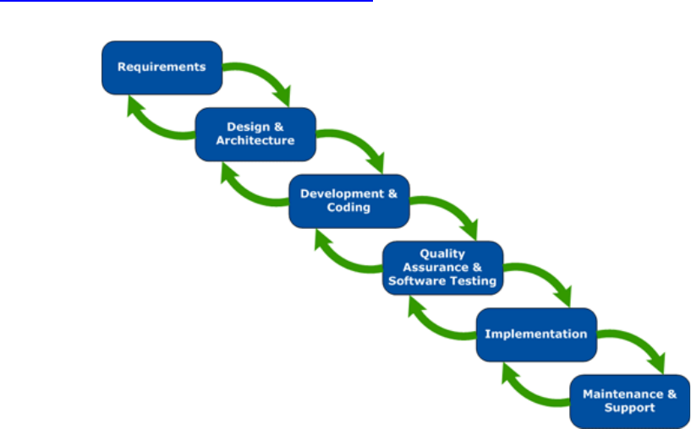

Figure 1 Modified Waterfall Model

*References: Wicked Problems, Righteous Solutions: A Catalogue of Modern Software Engineering Paradigms, Yourdon Press, 1990*

### Roles and responsibilities

|  |  |  |  |
| --- | --- | --- | --- |
| No | Full name | Role in Group | Responsibilities |
| 1 | Lại Đức Hùng | Product Owner | * Specify user requirement * Control the development process * Give out technique and business analysis support |
| 2 | Nguyễn Lữ Đại Sơn | Team Leader | * Managing project * Designing databases * Clarifying requirements * Prepare documents * GUI Design * Create test plan * Coding * Testing * Arrange Meeting * Risk Management |
| 3 | Đoàn Văn Công | Team Member | * Clarifying requirements * Prepare documents * GUI Design * Create test plan * Coding * Testing * Arrange Meeting * Risk Management |

Table 6 Roles and responsibilities

### Tools and Techniques

|  |  |
| --- | --- |
| Tool/Technique | Name |
| Front-end | HTML, CSS, JavaScript, AJax |
| Back-end | JavaEE, Spring, JPA, Hibernate |
| IDE | IntelliJ IDEA 17.2, Android Studio 3.0 |
| DBMS | SQL Server 2014 |
| Source Control | SourceTree, Github |
| Modelling tool | StarUML |

Table 7 Tools and techniques

## Project Management Plan

### Software development life cycle

| **Phase** | **Description** | **Deliverables** | **Resource needed** | **Dependencies and Constrains** | **Description** |
| --- | --- | --- | --- | --- | --- |
| Requirement Analysis | Collect and analyze system requirements | Software Requirement Specification | 20 man- days | N/A | * Missing requirement * Unclear scope project’s scope * Lack of member share of understanding |
| System and Software Design | * Design the structure of the system * Choose Architecture style | Software Design Document | 20 man- days | Depend on requirement after analyzed and system architecture design. | * Lack of experience from real project * Requirement is too complex and easy to misunderstand |
| Implementation and Unit Testing | * Implement all system’s function * Create test plan * Perform Unit test | Software package and hardware | 50 man- days | Depend on Software Requirement Specification, Software Design Description and Hardware | * Lack of experience and knowledge * Human mistake * Hardware error |
| Integration and System Testing | * Integration test the system * Alpha test * Correct bugs * Beta test | Test case | 20 man- days | Depend on “Implementation” | * Lack of experience * Missing test case |
| Operation and Maintenance | Deploy on sever, web and mobile | * Installation guide * Software User’s Manual | 10 man- days | Depend on “Testing” | * Lack of experience * Customers do not understand User’s Manual |

Table 8 Software development life cycle

### Phase detail

#### 

| **Task** | **Description** | **Author** |
| --- | --- | --- |
| **1. Collect requirements** | Research similar application to collect requirement.  Observation real situation. | SonNLD, CongDV |
| **2. Identify and clarify main functions** | Define main system’s function. | SonNLD, CongDV |
| **3. Create System** **Introduction** | Complete Introduction Report. | SonNLD, CongDV |
| **4. Software Project**  **Management Plan** | Create Project Management Plan. | SonNLD, CongDV |
| **5. Prototype** | Build a prototype of proposed system (Website/Mobile). | SonNLD, CongDV |
| **6. SRS** | Create Software Requirement Specification document. | SonNLD, CongDV |

Table 9 Phase 1: Requirements Analysis

#### Phase 2: Design

|  |  |  |
| --- | --- | --- |
| Task | Description | Author |
| 1. Database Design | Design database for the RFIM system | SonNLD, CongDV |
| 2. Technology research | Study Arduino platform  Study Bluetooth on Mobile Device Technology | SonNLD, CongDV |
| 3. Design Document | Create software design document | SonNLD, CongDV |

Table 10 Phase 2: Design

#### Phase 3: Implementation

|  |  |  |
| --- | --- | --- |
| **Task** | **Description** | **Author** |
| **1. HSB’s functions** | Implement function of HSB system | SonNLD, CongDV |
| **2. Front-end web functions** | Implement front-end functions on web | CongDV |
| **3. Back-end web functions** | Implement back-end functions on web | SonNLD |
| **4. Mobile functions** | Implement mobile application | SonNLD, CongDV |
| **5. Unit testing** | Write test case and test for web functions | SonNLD, CongDV |
| Write test case and testing for mobile functions | SonNLD, CongDV |

Table 11. Phase 3: Implementation

#### Phase 4: Testing

|  |  |  |
| --- | --- | --- |
| **Task** | **Description** | **Author** |
| **1. Integration testing** | Write test case and test systems | SonNLD, CongDV |
| **2. Acceptance testing** | Let customer test real product to ensure the product meet user’s requirements | SonNLD, CongDV |

Table 12. Phase 4: Testing

#### Phase 5: Operation and Maintenance

|  |  |  |
| --- | --- | --- |
| **Task** | **Description** | **Author** |
| **1. Installation guide** | Write installation guide | SonNLD, CongDV |
| **2. Create User’s Manual** | Write user manual | SonNLD, CongDV |

Table 13. Phase 5: Operation and Maintenance

### All Meeting Minutes

All meeting documents could be found here: <https://drive.google.com/drive/u/0/folders/1hkR4M_5a6QBYsx1qS_sAAU3sBlKEoR0U?fbclid=IwAR0YHgC-MXGCdnHh6BE6vMzzaL2U-DOmcqkS0piBXvHaBKXUBlaIkd7-5mU>

## Coding Convention

Summary:

* Naming Convention:
  + Variable names should be short yet meaningful. The choice of a variable name should be designed to indicate to the casual observer the intent of its use.
  + Methods should be verbs, in mixed case with the first letter lowercase, with the first letter of each internal word capitalized.
* Indentation:
  + One declaration per line is recommended since it encourages commenting.
  + In absolutely no case should variables and functions be declared on the same line.
  + Do not put different types on the same line.
* Declarations Convention:
  + One declaration per line is recommended since it encourages commenting.
  + Using Java Code Convention from:

<http://www.oracle.com/technetwork/java/codeconvtoc-136057.html>

# Software Requirement Specification

## User Requirement Specification

### Guest requirement

**Guest** is a person who doesn’t have access to the system. Guest can only use some functions in the system. To use all functions, guest must login. These are some functions guest can use:

* Login
* Register
* Find salon by location
* Find service by service’s name
* Find best services by review and rating

### Customer requirement

**Customer** is an authorized user has permission to log in to the system. With customer role, user can perform the following functions:

* Customer can view services of salon
* Customer can book services
* Customer can cancel booking
* Customer can find the best salon with a few criteria such as: by discount, by location, by review and rating.
* Customer can check as well as view the booking history.
* Customer can cancel booking schedule.

### Salon Manager requirement

**Salon Manager** is an authorized user has permission to login to the system. With staff role, user can perform the following functions:

* Manager can manage service: add new services, update service’s information and may be remove services.
* Manager can manage booking schedule

### Admin requirement

**Admin** is an authorized user has permission to log in to the system. An admin has higher authority than the others. In addition, an admin can do the following functions:

* Admin can manage customer includes: activate or deactivate account of customer
* Admin can manage salon include: activate or deactivate salon

## System Requirement Specification

### External Interface Requirement

#### User Interface:

* GUI should be simple, clear, intuitive, and reminiscent.
* The interface design is an iterate process includes: design, sketching, prototyping, user assessment.
* The language is Vietnamese

#### Hardware Interface

* PC: connected to Wifi, 4GB of RAM minimum, CPU 1.4GHz.
* Android device: connected to Wifi or LTE, connected to Bluetooth v4.0 or higher, 1GB of RAM minimum, CPU 1.2 GHz.

#### Software Interface

* Web application: work with browsers Firefox (v52 or higher), Chromes (v28 or higher), Internet Explorer (v10 or above) or with any web browser that supports HTML5 & CSS3.
* Mobile application: Android (5.0 or higher)

#### Communication Protocol

* Use HTTP protocol 1.1 for communication between the web browser and the web server.

### System Overview Use Case

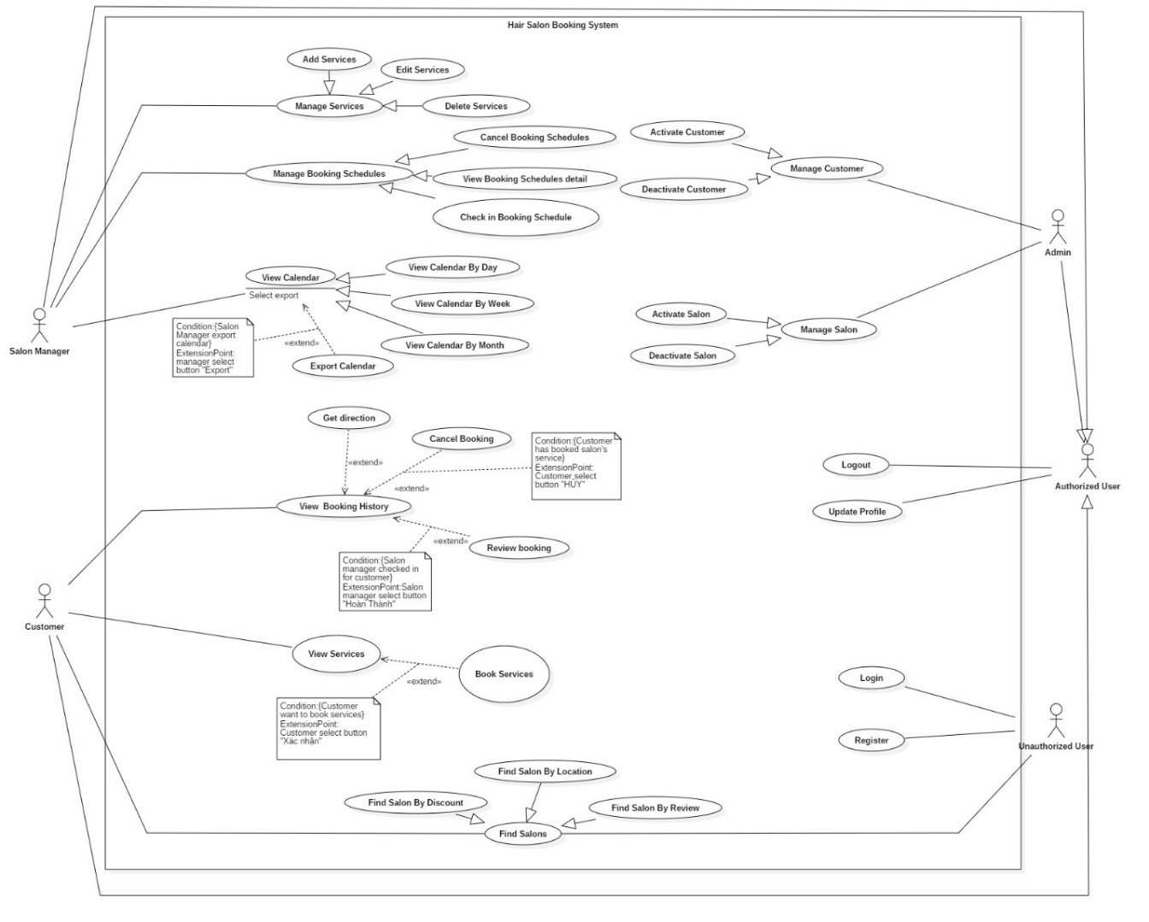

Figure 2 System overview use case

### List of use case

#### <Guest> Overview Use Case

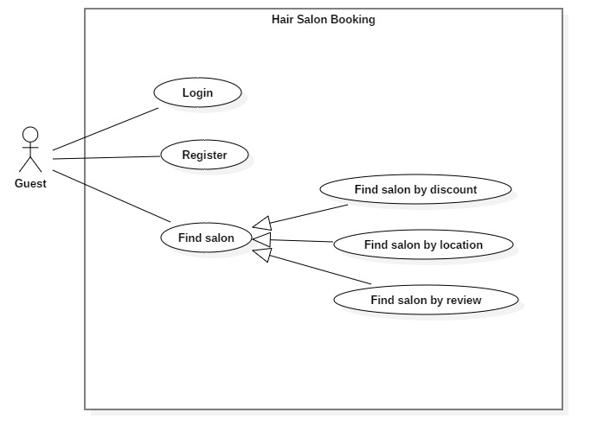

Figure 3: <Guest> Overview use case

##### <Guest> Login

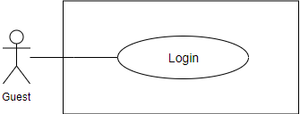

Figure 4 <Guest> Login

**Use Case Specification**

|  |  |  |  |
| --- | --- | --- | --- |
| **USE CASE – HSB_UC_01** | | | |
| **Use Case No.** | **HSB_UC_01** | Use Case Version | 1.1 |
| **Use Case Name** | Login | | |
| **Author** | Doan Van Cong | | |
| **Date** | 01/06/2019 | **Priority** | Normal |
| **Actor:**   * Guest   **Summary:**   * This use case allows user to login to the system.   **Goal:**   * Guest can login to the system   **Trigger:**   * Guest input username and password and click login   **Precondition:**   * Guest is on login screen   **Post Conditions:**   * Success: User login to the system successfully * Fail: Show error messages   **Main Success Scenario:**   |  |  |  | | --- | --- | --- | | Step | Actor Action | System Response | | 1 | Guest goes to the login screen | The system requires the following input from User includes:   * Username: text, required * Password: text, required | | 2 | User inputs information. |  | | 3 | User clicks button “Đăng nhập” | The system show message that the user has logged in successfully  [Exception 1] |   **Exception 1:**   |  |  |  | | --- | --- | --- | | **Step** | **Cause** | **System Response** | | 1 | Invalid username or password | System shows message “Tên đăng nhập hoặc mật khẩu không đúng” |   **Relationship:** N/A.  **Business rule:**   * User password character is secured and hidden with special character | | | |

<Guest> Login Use Case Specification

##### <Guest> Register

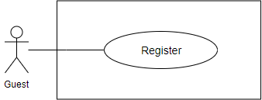

Figure 5 <Guest> Register

**Use Case Specification**

|  |  |  |  |
| --- | --- | --- | --- |
| **USE CASE - HSB_UC_02** | | | |
| **Use Case No.** | CCP_UC_02 | Use Case Version | 1.1 |
| **Use Case Name** | Register | | |
| **Author** | Doan Van Cong | | |
| **Date** | 01/06/2019 | **Priority** | Normal |
| **Actor**:   * Guest   **Summary**:   * This use case allows user to register an account   **Goal**:   * Guest can register an account   **Trigger**:   * Guest input information and click “Đăng ký” button.   **Precondition**:   * Guest is viewing the register screen.   **Post Conditions:**   * Success: User registers to the system successfully. * Fail: Show error messages.   **Main Success Scenario:**   |  |  |  | | --- | --- | --- | | **Step** | **Actor Action** | **System Response** | | 1 | Guest goes to the register screen | The system requires the following input from Guest includes:   * Username: text, required * Password: text, required * Confirm password: text, required * Name: text, required * Email: text, required * Phone: text as number, required | | 2 | Guest inputs information. |  | | 3 | Guest clicks “Đăng kí” | The system check validation and show message that the user has registered successfully  [Exception 1] |   Exception 1:   |  |  |  | | --- | --- | --- | | **Step** | **Cause** | **System Response** | | 1 | Username is used by another account | System shows message “Tên đăng nhập đã tồn tại” |   **Relationship**: N/A.  **Business** rule:   * Password and confirm password field must be hidden with special character * The system validates user input with the following constraints:   + Username: unique and have more than 6 and less than 20 character   + Phone number: number format   + Email: email format   + Password: Have more than 6 and less than 20 character   + The confirm password matches the password | | | |

##### <Guest> Find salon by location

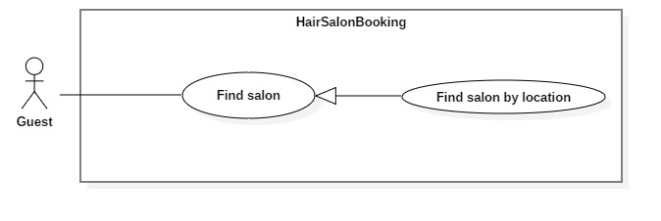

Figure 6 <Guest> Find salon by location

**Use Case Specification**

|  |  |  |  |
| --- | --- | --- | --- |
| **USE CASE - HSB_UC_03** | | | |
| **Use Case No.** | **HSB_UC_03** | **Use Case Version** | 1.1 |
| **Use Case Name** | Find salon by location | | |
| **Author** | Doan Van Cong | | |
| **Date** | 01/06/2019 | **Priority** | Normal |
| **Actor:**   * Guest   **Summary:**   * This use case allows user to find salon by location in the system.   **Goal:**   * Guest can see the list of salons.   **Trigger:**   * Guest click on location button.   **Precondition:**   * Guest is on home screen.   **Post Conditions:**   * Success: List of all nearby salon will be displayed on map. * Fail: Show error messages.   **Main Success Scenario:**   |  |  |  | | --- | --- | --- | | **Step** | **Actor Action** | **System Response** | | 1 | Guest click on location button | Show all nearby salon on map.  [Exception 1] |   **Exception 1:**   |  |  |  | | --- | --- | --- | | **No** | **Cause** | **System Response** | | 1 | Guest don’t enable GPS | System shows message "Bạn có muốn bật định vị không?" with two options “có” and “không”.  Guest select option “có”: Open location setting. Guest can open GPS from here.  Guest select option “Không”: Return to home screen. |   **Relationship:** N/A.  **Business rule:**   * + Display salon icon on map when show salon   + Display salon in selected radius.   + Show salon detail when click on icon. | | | |

##### <Guest> Find salon by discount

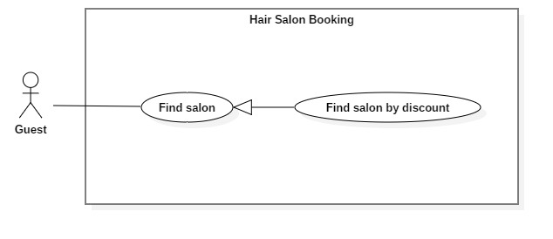

Figure 7 <Guest> Find salon by discount

**Use Case Specification**

|  |  |  |  |
| --- | --- | --- | --- |
| **USE CASE - HSB_UC_04** | | | |
| **Use Case No.** | **HSB_UC_04** | **Use Case Version** | 1.1 |
| **Use Case Name** | Find salon by discount | | |
| **Author** | Doan Van Cong | | |
| **Date** | 30/07/2019 | **Priority** | Normal |
| **Actor:**   * Guest   **Summary:**   * This use case allows guest to find salon by discount   **Goal**  **-** Guest can see the result list of service with corresponding search value.  **Trigger:**   * Guest input service name on search filter.   **Precondition:**   * Guest is on home screen.   **Post Conditions:**   * Success: List of service with corresponding search value will be displayed.   **Main Success Scenario:**   |  |  |  | | --- | --- | --- | | **Step** | **Actor Action** | **System Response** | | 1 | Guest input service name on search filter. | The system will display list of service with corresponding search value. |   **Relationship:** N/A.  **Business rule:**   * Guest will get the search results list. * Show show detail for each service. * After Guest search, the material list can be sorted by time, price | | | |

##### <Guest> Find salon by review

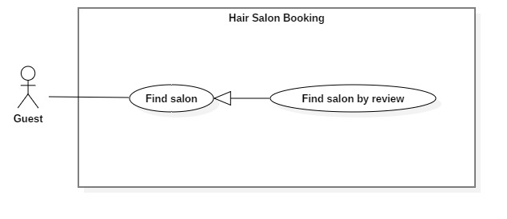

**Use Case Specification**

|  |  |  |  |
| --- | --- | --- | --- |
| **USE CASE - HSB_UC_05** | | | |
| **Use Case No.** | **HSB_UC_05** | **Use Case Version** | 1.1 |
| **Use Case Name** | Find salon by review | | |
| **Author** | Doan Van Cong | | |
| **Date** | 30/07/2019 | **Priority** | Normal |
| **Actor:**   * Guest   **Summary:**   * This use case allows guest to find salon by review   **Goal**  **-** Guest can see the result list of salon sorted by rating of review  **Trigger:**   * Guest is on Home screen   **Precondition:**   * Guest is on Home screen.   **Post Conditions:**   * Success: List of salons will be sorted by rating of review and displayed in Home screen.   **Main Success Scenario:**   |  |  |  | | --- | --- | --- | | **Step** | **Actor Action** | **System Response** | | 1 | Guest is on Home screen. | List of salons will be sorted by rating of review and displayed in Home screen. |   **Relationship:** N/A.  **Business rule:**   * List of salon will be sorted in ascending order. | | | |

#### <Customer> Overview Use Case

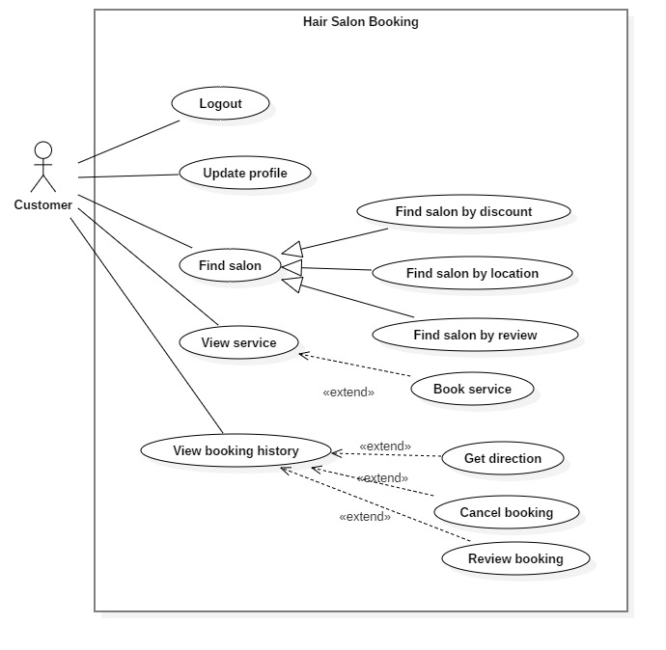

Figure 8 <Customer>Overview use case

##### <Customer> Logout

**Use Case Specification**

|  |  |  |  |
| --- | --- | --- | --- |
| **USE CASE - HSB_UC_06** | | | |
| **Use Case No.** | **HSB_UC_06** | **Use Case Version** | 1.1 |
| **Use Case Name** | Logout | | |
| **Author** | Doan Van Cong | | |
| **Date** | 31/07/2019 | **Priority** | Normal |
| **Actor:**   * Customer   **Summary:**   * This use case allows user to logout to the system.   **Goal:**   * Customer can logout from the system   **Trigger:**   * Customer sends a logout command.   **Precondition:**   * Customer is viewing the user detail screen   **Post Conditions:**   * Success: User logout to the system successfully * Fail: Show error messages   **Main Success Scenario:**   |  |  |  | | --- | --- | --- | | **Step** | **Actor Action** | **System Response** | | 1 | Customer go to the user detail view |  | | 2 | Customer clicks “Đăng xuất” | The system show message that the user has logged out successfully |   **Relationship:** N/A.  **Business rule:**   * After logged out, user access the system as role “Guest” * Return user to home screen after logged out. | | | |

##### <Customer> Find salon by location

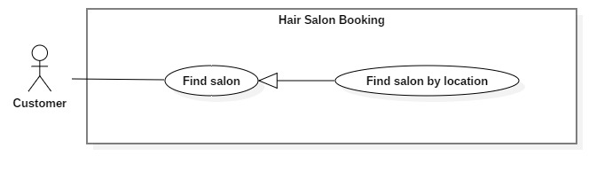

Figure 9 <Customer> Find salon by location

**Use Case Specification**

|  |  |  |  |
| --- | --- | --- | --- |
| **USE CASE - HSB_UC_05** | | | |
| **Use Case No.** | **HSB_UC_05** | **Use Case Version** | 1.1 |
| **Use Case Name** | Find salon by location | | |
| **Author** | Doan Van Cong | | |
| **Date** | 01/06/2019 | **Priority** | Normal |
| **Actor:**   * Customer   **Summary:**   * This use case allows user to find salon by location in the system.   **Goal:**   * Customer can see the list of salons.   **Trigger:**   * Customer click on location button.   **Precondition:**   * Customer is on home screen.   **Post Conditions:**   * Success: List of all nearby salon will be displayed on map. * Fail: Show error messages.   **Main Success Scenario:**   |  |  |  | | --- | --- | --- | | **Step** | **Actor Action** | **System Response** | | 1 | Customer click on location button | Show all nearby salon on map.  [Exception 1] |   **Exception 1:**   |  |  |  | | --- | --- | --- | | **No** | **Cause** | **System Response** | | 1 | Customer don’t enable GPS | System shows message "Bạn có muốn bật định vị không?" with two options “có” and “không”.  Guest select option “có”: Open location setting. Guest can open GPS from here.  Guest select option “Không”: Return to home screen. |   **Relationship:** N/A.  **Business rule:**   * + Display salon icon on map when show salon | | | |

##### <Customer> Find salon by discount

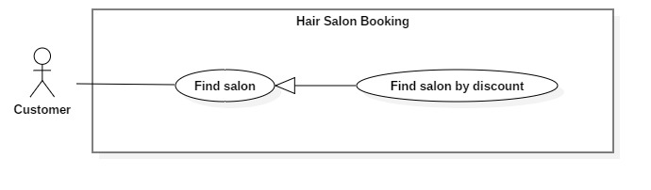

Figure 10 <Customer> Find salon by discount

**Use Case Specification**

|  |  |  |  |
| --- | --- | --- | --- |
| **USE CASE - HSB_UC_06** | | | |
| **Use Case No.** | **HSB_UC_06** | **Use Case Version** | 1.1 |
| **Use Case Name** | Find salon by discount | | |
| **Author** | Doan Van Cong | | |
| **Date** | 30/07/2019 | **Priority** | Normal |
| **Actor:**   * Customer   **Summary:**   * This use case allows customer to find salon by discount   **Goal**  **-** Customer can see the result list of service with corresponding search value.  **Trigger:**   * Customer input service name on search filter.   **Precondition:**   * Customer is on home screen.   **Post Conditions:**   * Success: List of service with corresponding search value will be displayed.   **Main Success Scenario:**   |  |  |  | | --- | --- | --- | | **Step** | **Actor Action** | **System Response** | | 1 | Customer input service name on search filter. | The system will display list of service with corresponding search value. |   **Relationship:** N/A.  **Business rule:**   * Customer will get the search results list. * After Guest search, the material list can be sorted by time, price | | | |

##### <Customer> View services

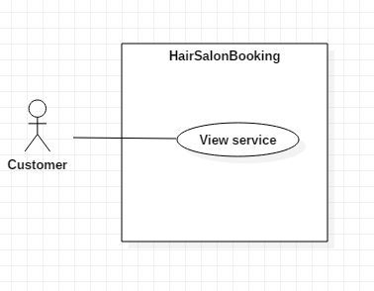

Figure 11 <Customer> View services

**Use Case Specification**

|  |  |  |  |
| --- | --- | --- | --- |
| **USE CASE - HSB_UC_07** | | | |
| **Use Case No.** | **HSB_UC_07** | **Use Case Version** | 1.0 |
| **Use Case Name** | View services | | |
| **Author** | Doan Van Cong | | |
| **Date** | 31/07/2019 | **Priority** | Normal |
| **Actor:**   * Customer   **Summary:**   * This use case allows customer to view service’s detail   **Goal:**   * Customer can view access and view the service’s detail screen   **Triggers:**   * Customer send view service command to the system.   **Preconditions:**   * Customer is in home screen or viewing the list of services after searching a service   **Post conditions:**   * Success: Customer can view access and view the service’s detail screen   **Main Success Scenario:**   |  |  |  | | --- | --- | --- | | **Step** | **Actor Action** | **System Response** | | 1 | Customer is in home screen or viewing the list of services after searching a service |  | | 2 | Customer click on a service. | Redirect to service’s detail screen to book services |   **Relationships:** N/A.  **Business Rules:**   * + The service’s detail screen contains:  1. Name of salon 2. Address of salon 3. Logo of salon 4. All service of salon 5. Discount percent 6. Price before and after discounting 7. Date and time picker to choose time to book | | | |

##### <Customer> Book services

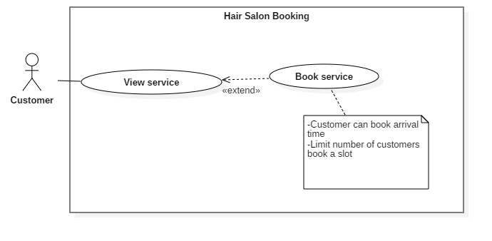

Figure 12<Customer> Book services

**Use Case Specification**

|  |  |  |  |
| --- | --- | --- | --- |
| **USE CASE - HSB_UC_08** | | | |
| **Use Case No.** | **HSB_UC_08** | **Use Case Version** | 1.0 |
| **Use Case Name** | Book services | | |
| **Author** | Doan Van Cong | | |
| **Date** | 31/07/2019 | **Priority** | Normal |
| **Actor:**   * Customer   **Summary:**   * This use case allows customer to book services   **Goal:**   * Customer successfully book services.   **Triggers:**   * Customer send booking command to the system.   **Preconditions:**   * Customer must login into the system with role user.   **Post conditions:**   * Success: User successfully book services * Fail: Show error message   **Main Success Scenario:**   |  |  |  | | --- | --- | --- | | **Step** | **Actor Action** | **System Response** | | 1 | Customer is in service’s detail screen |  | | 2 | Customer choose service, date and time to book |  | | 3 | Customer click button “Tiếp tục” | Redirect to confirm screen for user to review the booking detail  [Exception 1]  [Exception 2]  [Exception 3]  [Exception 4] | | 4 | Customer click button “Xác nhận” | Display successful message “Đặt chỗ thành công” |   **Exception 1:**   |  |  |  | | --- | --- | --- | | **No** | **Actor Action** | **System Response** | | 1 | Customer do not login to the system | System show error message “Bạn chưa đăng nhập” and redirect to Login sceen |   **Exception 2:**   |  |  |  | | --- | --- | --- | | **No** | **Actor Action** | **System Response** | | 1 | Customer do not choose services | System show error message “Bạn chưa chọn dịch vụ” |   **Exception 3:**   |  |  |  | | --- | --- | --- | | **No** | **Actor Action** | **System Response** | | 1 | Customer do not choose date | System show error message “Bạn chưa chọn ngày” |   **Exception 4:**   |  |  |  | | --- | --- | --- | | **No** | **Actor Action** | **System Response** | | 1 | Customer do not choose arrival time | System show error message “Bạn chưa chọn giờ” |   **Relationships:** View service  **Business Rules:**   * A booking schedule must have:  1. Name of customer 2. Name of salon 3. Service and price 4. Date and arrival time | | | |

##### <Customer> View booking history

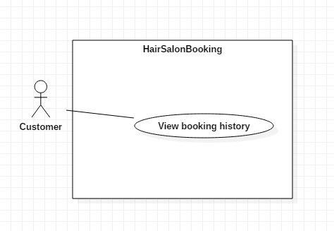

Figure 13<Customer> View booking history

**Use Case Specification**

|  |  |  |  |
| --- | --- | --- | --- |
| **USE CASE - HSB_UC_09** | | | |
| **Use Case No.** | **HSB_UC_09** | **Use Case Version** | 1.0 |
| **Use Case Name** | View booking history | | |
| **Author** | Doan Van Cong | | |
| **Date** | 31/07/2019 | **Priority** | Normal |
| **Actor:**   * Customer   **Summary:**   * This use case allows customer to view booking history   **Goal:**   * Customer can view booking history.   **Triggers:**   * Customer send view booking history command to the system.   **Preconditions:**   * Customer must login into the system with role User.   **Post conditions:**   * Success: View the booking history successfully * Fail: Show error message   **Main Success Scenario:**   |  |  |  | | --- | --- | --- | | **Step** | **Actor Action** | **System Response** | | 1 | Customer click “ Lịch sử đặt” on navigation menu | System redirect to booking history screen with list of booking schedule of user  [Exception 1] | | 2 | Customer click on a booking schedule | System redirect to booking history detail screen. User can view all information of booking schedule. |   **Exception** **1:**   |  |  |  | | --- | --- | --- | | **No** | **Actor Action** | **System Response** | | 1 | Customer do not have booking schedule | System show message “Bạn chưa có lịch hẹn nào.” |   **Relationships:** N/A.  **Business Rules:**   * Display list of booking base on user’s id * A booking schedule must have:   1.Name of customer  2.Name of salon  3.Service and price  4.Date and arrival time | | | |

##### <Customer> Cancel booking

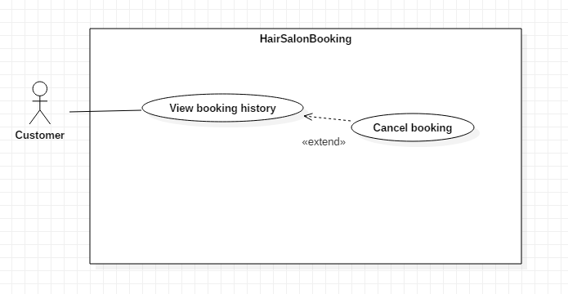

Figure 14 <Customer> Cancel booking

|  |  |  |  |
| --- | --- | --- | --- |
| **USE CASE - HSB_UC_10** | | | |
| **Use Case No.** | **HSB_UC_10** | **Use Case Version** | 1.0 |
| **Use Case Name** | Cancel booking | | |
| **Author** | Doan Van Cong | | |
| **Date** | 31/07/2019 | **Priority** | Normal |
| **Actor:**   * Customer   **Summary:**   * This use case allows customer to cancel booking schedule   **Goal:**   * User cancel booking schedule successfully.   **Triggers:**   * User send cancel booking command to the system.   **Preconditions:**   * User must login into the system with role User.   **Post conditions:**   * Success: Booking schedule was canceled successfully * Fail: Show error message   **Main Success Scenario:**   |  |  |  | | --- | --- | --- | | **Step** | **Actor Action** | **System Response** | | 1 | User click “ Lịch sử đặt” on navigation menu | System redirect to booking history screen with list of booking schedule of user | | 2 | User click on a booking schedule | System redirect to booking history detail screen. User can view all information of booking schedule. | | 3 | User click “Hủy đặt chỗ” | System will show message “Đã hủy đặt chỗ” and return to booking history screen |   **Relationships:** View booking history  **Business Rules:**   * Status of booking will be change to “Đã hủy” | | | |

##### <Customer> Review booking

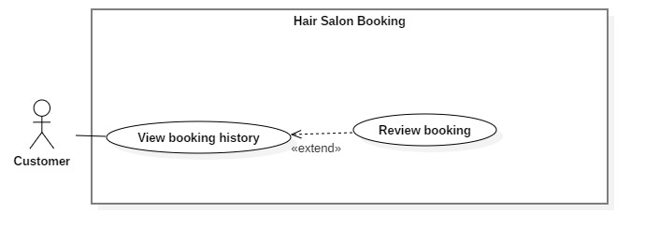

**Use Case Specification**

|  |  |  |  |
| --- | --- | --- | --- |
| **USE CASE - HSB_UC_11** | | | |
| **Use Case No.** | **HSB_UC_11** | **Use Case Version** | 1.0 |
| **Use Case Name** | Review booking | | |
| **Author** | Doan Van Cong | | |
| **Date** | 31/07/2019 | **Priority** | Normal |
| **Actor:**   * Customer   **Summary:**   * This use case allows customer to review and rate booking schedule   **Goal:**   * Customer can review and rate booking schedule successfully   **Triggers:**   * Customer send review and rate booking schedule command to the system.   **Preconditions:**   * Customer must login into the system with role User. * Customer must use services of salon and status of booking schedule is “Đã hoàn thành”   **Post conditions:**   * Success: Review and rate booking schedule successfully * Fail: Show error message   **Main Success Scenario:**   |  |  |  | | --- | --- | --- | | **Step** | **Actor Action** | **System Response** | | 1 | Customer click “ Lịch sử đặt” on navigation menu | System redirect to booking history screen with list of booking schedule of user  [Exception 1] | | 2 | Customer click on a booking schedule | System redirect to booking history detail screen. User can view all information of booking schedule. | | 3 | Customer click button “Đánh giá” | System redirect to review screenory detail screen. | | 4 | Customer give comment and rate the booking then click button “Hoàn thành” | System will show message “Đánh giá thành công” and return to booking schedule detail screen |   **Exception** **1:**   |  |  |  | | --- | --- | --- | | **No** | **Actor Action** | **System Response** | | 1 | Customer do not have booking schedule | System show message “Bạn chưa có lịch hẹn nào.” |   **Relationships:** N/A.  **Business Rules:**   * Customer must use services of salon and status of booking schedule is “Đã hoàn thành” | | | |

#### <Salon Manager> Overview Use Case

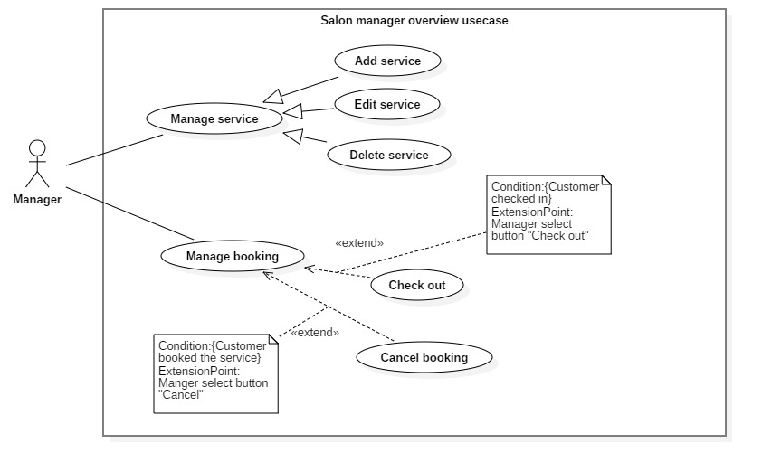

Figure 15<Salon Manager> Overview use case

##### <Salon Manager> Add services

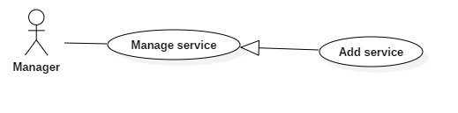

Figure 16 <Salon Manager> Add services

**Use Case Specification**

|  |  |  |  |
| --- | --- | --- | --- |
| **USE CASE – HSB_UC_11** | | | |
| **Use Case No.** | **HSB_UC_11** | **Use Case Version** | 2.0 |
| **Use Case Name** | Add services | | |
| **Author** | Nguyen Lu Dai Son | | |
| **Date** | 01/08/2019 | **Priority** | High |
| **Actor:**   * Salon Manager   **Summary:**   * This use case allows Salon Manager to create new service   **Goal:**   * Salon Manager successfully create new service   **Triggers:**   * Salon Manager click “Tạo dịch vụ mới”   **Preconditions:**   * User must login to the system * Salon Manager account must be activated   **Post conditions:**   * Success:   + Salon Manager successfully create new service * Fail: Show error message   **Main Success Scenario:**   |  |  |  | | --- | --- | --- | | **Step** | **Actor Action** | **System Response** | | 1 | User click “Tạo dịch vụ mới” | System redirect to add service screen | | 2 | User input fields | System show message that the service is created.  [Exception 1] |   **Exceptions:**   |  |  |  | | --- | --- | --- | | **No** | **Cause** | **System Response** | | 1 | User input invalid fields | System shows message with correspoding fields:  Tên dịch vụ: Phải có 6 đến 20 ký tự.  Giảm giá: Từ 0 đến 90%.  Giá tiền: Từ 10 đến 99999k |   **Relationships:** N/A  **Business Rules:**   * Salon Manager can view the details of service before click “Hoàn thành”. * When Salon Manager click “Hoàn thành”:   + Show message “Đã thêm 1 dịch vụ”.   + Redirect to “Dánh sách dịch vụ” screen. | | | |

##### <Salon Manager> Edit service

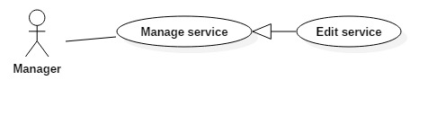

Figure 17<Salon Manager> Edit service

**Use Case Specification**

|  |  |  |  |
| --- | --- | --- | --- |
| **USE CASE – HSB_UC_12** | | | |
| **Use Case No.** | **HSB_UC_12** | **Use Case Version** | 1.0 |
| **Use Case Name** | Edit service | | |
| **Author** | Nguyen Lu Dai Son | | |
| **Date** | 01/06/2018 | **Priority** | Normal |
| **Actor:**   * Salon Manager   **Summary:**   * This use case allows salon manager to edit service information.   **Goal:**   * Salon Manager edit service information.   **Triggers:**   * Salon Manager click “Sửa” button.   **Preconditions:**   * User must login to the system   **Post conditions:**   * Success:   + User successfully save the edited service. * Fail: Show error message   **Main Success Scenario:**   |  |  |  | | --- | --- | --- | | **Step** | **Actor Action** | **System Response** | | 1 | User click “Sửa” button. | System redirect user to edit service page. | | 2 | User input date to fields . |  | | 3 | User click”Lưu” button. | System redirect user to list service page.  [Exception 1] |   **Exceptions:**   |  |  |  | | --- | --- | --- | | **No** | **Cause** | **System Response** | | 1 | User input invalid fields. | System shows message with corresponding fields. |   **Relationships:** N/A  **Business Rules:**   * This action help Salon Manage to update service information. * Service information must be valid before save to database. | | | |

##### <Salon Manager> Delete services

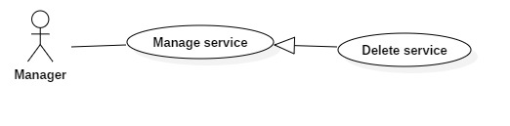

Figure 18<Salon Manager> Delete services

**Use Case Specification**

|  |  |  |  |
| --- | --- | --- | --- |
| **USE CASE – HSB_UC_13** | | | |
| **Use Case No.** | **HSB_UC_13** | **Use Case Version** | 1.1 |
| **Use Case Name** | Delete services | | |
| **Author** | Nguyen Lu Dai Son | | |
| **Date** | 01/06/2018 | **Priority** | High |
| **Actor:**   * Salon Manager   **Summary:**   * This use case allows supplier to deny a pending hiring transaction for an equipment from a requester   **Goal:**   * Salon Manager delete a service.   **Triggers:**   * Salon Manager click button “Xóa”   **Preconditions:**   * User must login to the system * User is on “danh sách dịch vụ screen”.   **Post conditions:**   * Success: Status of service from active to disable. * Fail: Show error message   **Main Success Scenario:**   |  |  |  | | --- | --- | --- | | **Step** | **Actor Action** | **System Response** | | 1 | User click button “Xóa” | System ask user to confirm the action | | 2 | User choose to confirm the action | System show message that service is deleted. |   **Relationships:** N/A  **Business Rules:**   * Salon Manager can view the service name before delete. * When Salon Manager click delete:   + Status of service from active to disable. | | | |

##### <Salon Manager> Cancel booking

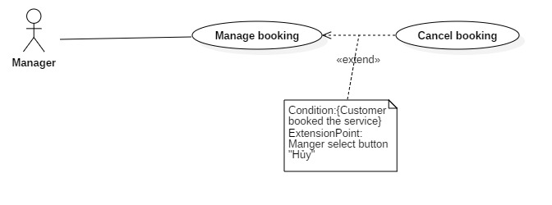

Figure 19<Salon manager> Cancel booking

**Use Case Specification**

|  |  |  |  |
| --- | --- | --- | --- |
| **USE CASE – HSB_UC_14** | | | |
| **Use Case No.** | **HSB_UC_14** | **Use Case Version** | 1.1 |
| **Use Case Name** | Cancel booking | | |
| **Author** | Nguyen Lu Dai Son | | |
| **Date** | 03/08/2018 | **Priority** | High |
| **Actor:**   * Salon Manager   **Summary:**   * This use case allows salon manager to cancel a booking.   **Goal:**   * Salon Manager cancel a booking.   **Triggers:**   * Salon Manager click button “Hủy”   **Preconditions:**   * User must login to the system * User must have booked before * User is on “danh sách đặt lịch screen”.   **Post conditions:**   * Success: Status of service change from process to cancel. * Fail: Show error message   **Main Success Scenario:**   |  |  |  | | --- | --- | --- | | **Step** | **Actor Action** | **System Response** | | 1 | User click button “Hủy” | System ask user to confirm the action. | | 2 | User choose to confirm the action | System show change status of booking. |   **Relationships:**Manage booking  **Business Rules:**   * Salon Manager must confirm the action before system change status of booking. | | | |

##### <Salon Manager> Finish booking

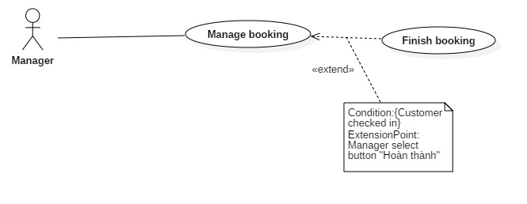

Figure 20<Salon manager> Cancel booking

**Use Case Specification**

|  |  |  |  |
| --- | --- | --- | --- |
| **USE CASE – HSB_UC_15** | | | |
| **Use Case No.** | **HSB_UC_15** | **Use Case Version** | 1.1 |
| **Use Case Name** | Finish booking | | |
| **Author** | Nguyen Lu Dai Son | | |
| **Date** | 03/08/2018 | **Priority** | High |
| **Actor:**   * Salon Manager   **Summary:**   * This use case allows salon manager to finish a booking.   **Goal:**   * Salon Manager cancel a booking.   **Triggers:**   * Salon Manager click button “Hoàn thành”   **Preconditions:**   * User must login to the system * User is on “danh sách đặt lịch screen”.   **Post conditions:**   * Success: Status of service change from process to finish. * Fail: Show error message   **Main Success Scenario:**   |  |  |  | | --- | --- | --- | | **Step** | **Actor Action** | **System Response** | | 1 | User click button “Hoàn thành” | System ask user to confirm the action. | | 2 | User choose to confirm the action | System show change status of booking. |   **Relationships:** Manage booking  **Business Rules:**   * Salon Manager must confirm the action before system change status of booking. | | | |

#### <Admin> Overview Use Case

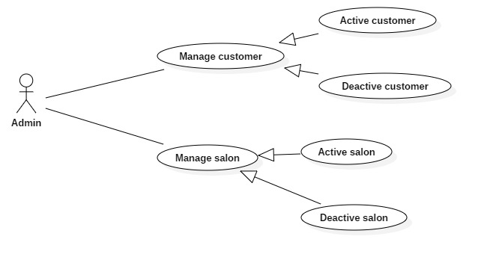

Figure 21<Admin>Overview use case

##### <Admin> Active customer

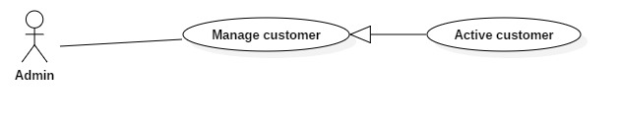

Figure 22<Admin> Active customer

**Use Case Specification**

|  |  |  |  |
| --- | --- | --- | --- |
| **USE CASE – HSB_UC_16** | | | |
| **Use Case No.** | **HSB_UC_16** | **Use Case Version** | 1.1 |
| **Use Case Name** | Active customer | | |
| **Author** | Nguyen Lu Dai Son | | |
| **Date** | 03/08/2018 | **Priority** | High |
| **Actor:**   * Admin   **Summary:**   * This use case allows admin to active a customer account.   **Goal:**   * Admin active a customer account.   **Triggers:**   * Admin click button “Kích hoạt”   **Preconditions:**   * User must login to the system as admin * User is on “danh sách người dùng screen”.   **Post conditions:**   * Success: Status of customer account change from deactive to active. * Fail: Show error message   **Main Success Scenario:**   |  |  |  | | --- | --- | --- | | **Step** | **Actor Action** | **System Response** | | 1 | User click button “Kích hoạt” | System ask user to confirm the action. | | 2 | User choose to confirm the action | System reload list of customer. |   **Relationships:** N/A  **Business Rules:**   * Admin must confirm the action before system change status of customer account. | | | |

##### <Admin> Deactive customer

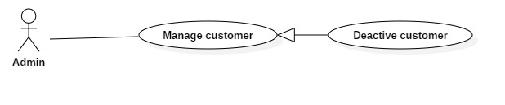

Figure 23<Admin> Deactive customer

**Use Case Specification**

|  |  |  |  |
| --- | --- | --- | --- |
| **USE CASE – HSB_UC_17** | | | |
| **Use Case No.** | **HSB_UC_17** | **Use Case Version** | 1.1 |
| **Use Case Name** | Deactive customer | | |
| **Author** | Nguyen Lu Dai Son | | |
| **Date** | 03/08/2018 | **Priority** | High |
| **Actor:**   * Admin   **Summary:**   * This use case allows admin to deactive a customer account.   **Goal:**   * Admin deactive a customer account.   **Triggers:**   * Admin click button “Khóa”   **Preconditions:**   * User must login to the system as admin * User is on “danh sách người dùng screen”.   **Post conditions:**   * Success: Status of customer account change from active to deactive. * Fail: Show error message   **Main Success Scenario:**   |  |  |  | | --- | --- | --- | | **Step** | **Actor Action** | **System Response** | | 1 | User click button “Khóa” | System ask user to confirm the action. | | 2 | User choose to confirm the action | System reload list of customer. |   **Relationships:** N/A  **Business Rules:**   * Admin must confirm the action before system change status of customer account. | | | |

##### <Admin> Active salon

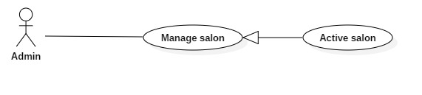

Figure 24<Admin>Active salon

**Use Case Specification**

|  |  |  |  |
| --- | --- | --- | --- |
| **USE CASE – HSB_UC_18** | | | |
| **Use Case No.** | **HSB_UC_18** | **Use Case Version** | 1.1 |
| **Use Case Name** | Active salon | | |
| **Author** | Nguyen Lu Dai Son | | |
| **Date** | 03/08/2018 | **Priority** | High |
| **Actor:**   * Admin   **Summary:**   * This use case allows admin to active a salon.   **Goal:**   * Admin active salon.   **Triggers:**   * Admin click button “Kích hoạt”   **Preconditions:**   * User must login to the system as admin * User is on “danh sách người dùng screen”.   **Post conditions:**   * Success: Status of salon change from deactive to active. * Fail: Show error message   **Main Success Scenario:**   |  |  |  | | --- | --- | --- | | **Step** | **Actor Action** | **System Response** | | 1 | User click button “Kích hoạt” | System ask user to confirm the action. | | 2 | User choose to confirm the action | System reload list of salon. |   **Relationships:** N/A  **Business Rules:**   * Admin must confirm the action before system change status of salon. | | | |

##### <Admin> Deactive salon

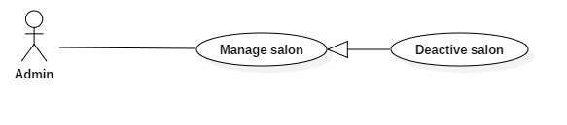

Figure 25 <Admin> Deactive salon

**Use Case Specification**

|  |  |  |  |
| --- | --- | --- | --- |
| **USE CASE – HSB_UC_19** | | | |
| **Use Case No.** | **HSB_UC_19** | **Use Case Version** | 1.1 |
| **Use Case Name** | Deactive salon | | |
| **Author** | Nguyen Lu Dai Son | | |
| **Date** | 03/08/2018 | **Priority** | High |
| **Actor:**   * Admin   **Summary:**   * This use case allows admin to deactive a salon.   **Goal:**   * Admin active salon.   **Triggers:**   * Admin click button “Khóa”   **Preconditions:**   * User must login to the system as admin * User is on “danh sách người dùng screen”.   **Post conditions:**   * Success: Status of salon change from active to deactive. * Fail: Show error message   **Main Success Scenario:**   |  |  |  | | --- | --- | --- | | **Step** | **Actor Action** | **System Response** | | 1 | User click button “Khóa” | System ask user to confirm the action. | | 2 | User choose to confirm the action | System reload list of salon. |   **Relationships:** N/A  **Business Rules:**   * Admin must confirm the action before system change status of salon. | | | |

## Software System Attribute

### Usability

* Website’s UI is fit for each browser on each device
* User can use after 2 hours training

### Reliability

* The system can run properly without crash.
* Mobile application and web admin can be operate while API is activated.

### Availability

* The system must be available at any time 24/7.

### Security

* Only Manager has fully access to the system
* Input data is validated before saving to database.

### Maintainability

* The system is divided into separated modules for easy maintain.

### Portability

* Web application can be run on Chrome browser version 42 or later

### Performance

* System has successfully test with basic standard
* Requests from web application are responded in less than 5 seconds at 4 Mbps bandwidth speed and 1GHz processing speed of CPU.

## Conceptual Diagram

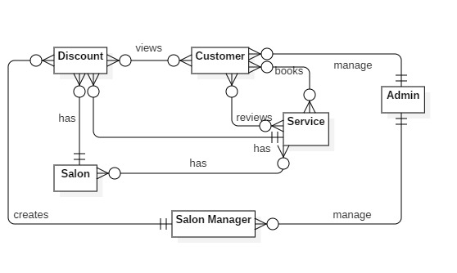

Figure 26 Conceptual Diagram

**Data Dictionary**

|  |  |
| --- | --- |
| **ENTITY DATA DICTIONARY: DESCRIBE ALL CONTENT OF ALL ENTITIES** | |
| **Entity Name** | **Description** |
| Admin | Contain the admin information |
| Customer | Contain the Customer information |
| Salon | Contain the Salon information |
| Salon manager | Contain the Salon manager information |
| Service | Contain the service information |
| Discount | Contain the discount information |

Table 14 Conceptual Diagram data dictionary

# Software Design Description

## Design Overview

This document describes the technical and user interface design of HSB system. It includes the architectural design, the detailed design of common functions and business functions and the design of database model.

The architectural design describes the overall architecture of the system and the architecture of each main component and subsystem.

The detailed design describes static and dynamic structure for each component and functions. It includes class diagrams, class explanations and sequence diagrams for each use cases.

 The database design describes the relationships between entities and details of each entity.

Document overview:

* Section 2: gives an overall description of the system architecture design.
* Section 3: gives component diagrams that describe the connection and integration of the system.
* Section 4: gives the detail design description which includes class diagram, class explanation, and sequence diagram to details the application functions.
* Section 5: describe screens design.
* Section 6: describe a fully attributed ERD.
* Section 7: describe algorithms.

## System Architecture Design

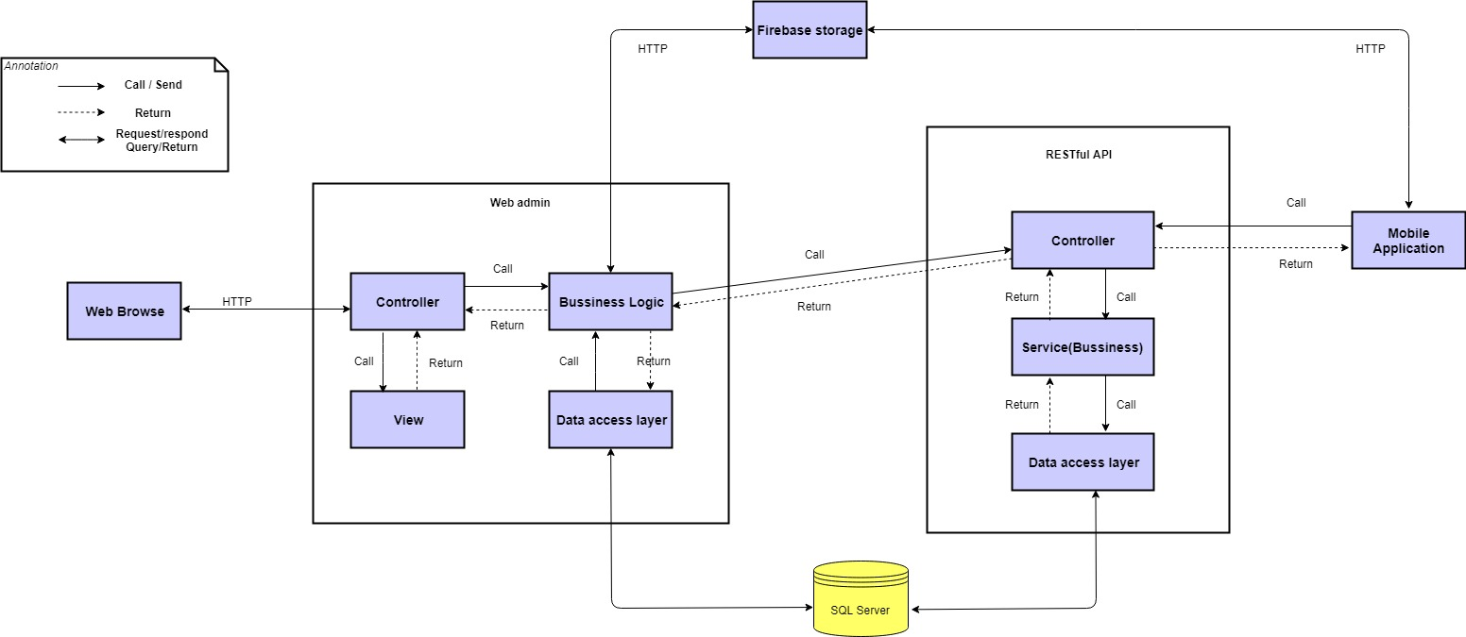

Figure 27 System Architecture diagram

### Admin web application

In Admin Web Application, the system is developed under MVC architecture style. We choose this architecture for Admin Web Application because the following advantages:

* Quickly to develop and maintain, because the lack of human resource of our team
* Have enough flexibility and maintainability, comprehension, convention because MVC model is a classical model with variety resources and eco system.
* Save memory leaks with small amount of Javascript because of server-side rendering
* No need heavy loading in client, save computing resources for devices in offices
* Preferable for simple applications

### Mobile application

In mobile application, we choose to develop an Android app system approach because of the following advantages:

* Provide rich user interface with many features.
* Better UX/UI for end users for quick data loading and background fetching
* Android java code is easy to master

## Component Diagram

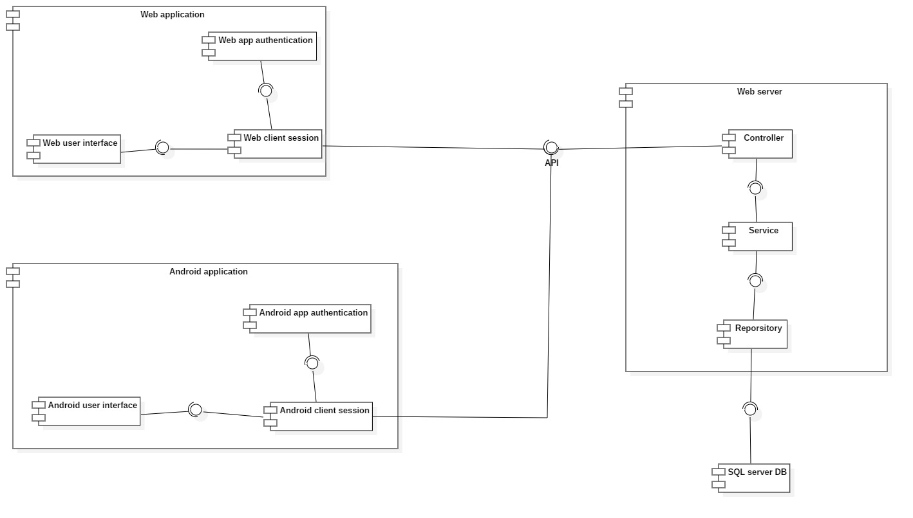

Figure 28 Component diagram

|  |  |
| --- | --- |
| COMPONENT DICTIONARY: DESCRIBES COMPONENTS | |
| Component name | **Description** |
| Web application | Contain all component of web app |
| Web app authentication | Provide authentication for web app |
| Web client session | Provide session for web app |
| Web user interface | Provide user interface for web app |
| Android Application | Contain all component of android app |
| Android app authentication | Provide authentication for android app |
| Android client session | Provide session for android app |
| Android user interface | Provide user interface for android app |
| Web server | Contain all component of web server |
| Controller | Provide access to service |
| Service | Provide access to repository |
| Repository | Provide access to database |
| SQL server DB | Store data |

Table 15 Component Dictionary

## Detailed Description

### Class Diagram

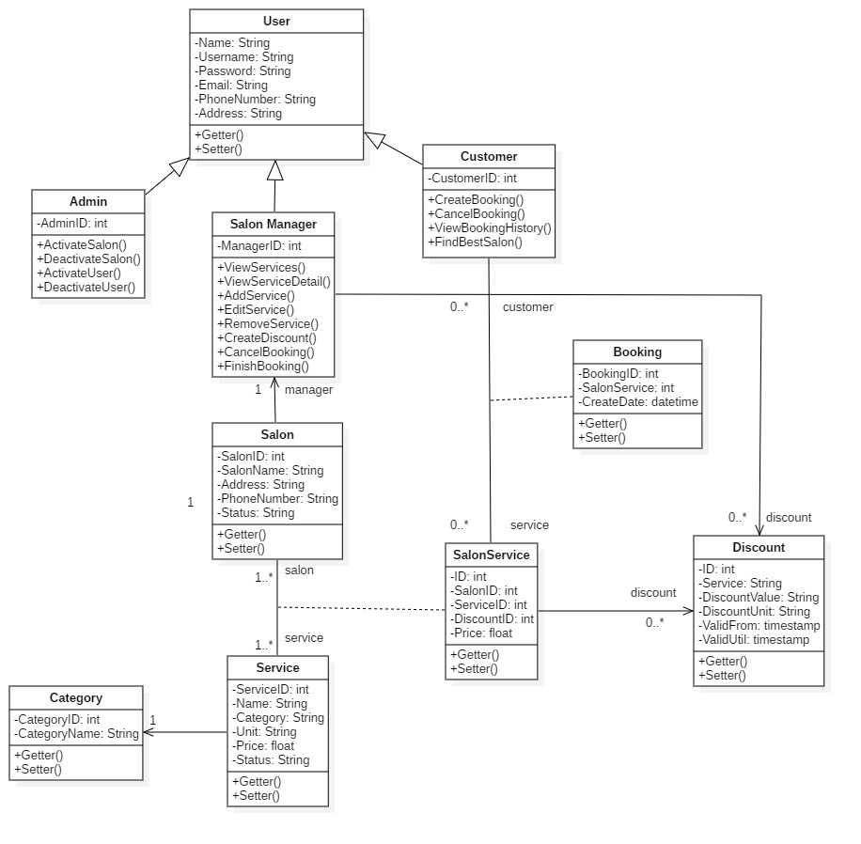

Figure 29 Class Diagram

### Class Diagram Explanation

|  |  |  |
| --- | --- | --- |
| **CLASS DICTIONARY: DESCRIBE CLASS** | | |
| **Class Name** | **Mapping column with Conceptual diagram** | **Description** |
| User | N/A | Contain User information |
| Admin | Admin | Contain Admin information |
| Salon manager | Salon manager | Contain Salon manager information |
| Customer | Customer | Contain Customer information |
| Booking | N/A | Contain Booking information |
| Discount | Discount | Contain Discount information |
| Salon | Salon | Contain Salon information |
| Service | Service | Contain Service information |
| Salon service | N/A | Contain Salon service information |
| Category | N/A | Contain Category information |

Table 16 Class Diagram Dictionary

#### User

* **Attributes**

|  |  |  |  |
| --- | --- | --- | --- |
| **Attribute** | **Type** | **Visibility** | **Description** |
| name | String | Private | User’s name |
| username | String | Private | User’s username |
| password | String | Private | User’s password |
| email | String | Private | User’s email |
| phone number | String | Private | User’s phone number |
| adddess | String | Private | User’s address |

Table 17 <Class Diagram> User Attribute

* **Methods**

|  |  |  |  |
| --- | --- | --- | --- |
| **Method** | **Return Type** | **Visibility** | **Description** |
| validateUsername() | boolean | public | User is validated or not |
| validatePassword() | boolean | public | Password is validated or not |

#### Admin

* Attributes

|  |  |  |  |
| --- | --- | --- | --- |
| **Attribute** | **Type** | **Visibility** | **Description** |
| adminID | Integer | Private | Admin’s ID |

Table 18 <Class Diagram> Admin Attribute

* **Methods**

|  |  |  |  |
| --- | --- | --- | --- |
| **Method** | **Return Type** | **Visibility** | **Description** |
| activate() | void | public | Activate customer or salon |
| deactivate() | void | public | Deactivate customer or salon |

#### Salon manager

* Attributes

|  |  |  |  |
| --- | --- | --- | --- |
| **Attribute** | **Type** | **Visibility** | **Description** |
| managerID | Integer | Private | Salon manager’s ID |

Table 19 <Class Diagram> Salon manager Attribute

* **Methods**

|  |  |  |  |
| --- | --- | --- | --- |
| **Method** | **Return Type** | **Visibility** | **Description** |
| viewService() | void | public | Get service’s detail |
| viewScheduleDetail() | void | public | Get booking schedule’s detail |
| addService() | boolean | public | Create new service |
| editService() | boolean | public | Update service |
| removeService() | boolean | public | Delete service |
| createDiscount() | boolean | public | Create new discount |
| cancelBooking() | boolean | public | Cancel a booking |
| finishBooking() | boolean | public | Finish a booking |

#### Customer

* Attributes

|  |  |  |  |
| --- | --- | --- | --- |
| **Attribute** | **Type** | **Visibility** | **Description** |
| customerID | Integer | Private | Customer’s ID |

Table 20 <Class Diagram> Customer Attribute

* **Methods**

|  |  |  |  |
| --- | --- | --- | --- |
| **Method** | **Return Type** | **Visibility** | **Description** |
| addBooking() | boolean | public | Book services |
| cancelBooking() | boolean | public | Cancel a booking schedule |
| viewBookingHistory() | void | public | View booking schedule history |
| findSalon() | Attribute type | public | Find a salon |

#### Booking

* Attributes

|  |  |  |  |
| --- | --- | --- | --- |
| **Attribute** | **Type** | **Visibility** | **Description** |
| bookingID | Integer | Private | Booking’s ID |
| salonServiceID | Integer | Private | Salon service‘s ID |
| createDate | dateTime | Private | Create date |

Table 21 <Class Diagram> Booking Attribute

* **Methods**

|  |  |  |  |
| --- | --- | --- | --- |
| **Method** | **Return Type** | **Visibility** | **Description** |
| getter() | attribute type | public | Get booking attributes |
| setter() | void | public | Set value of booking attributes |

#### Discount

* Attributes

|  |  |  |  |
| --- | --- | --- | --- |
| **Attribute** | **Type** | **Visibility** | **Description** |
| id | Integer | Private | ID of discount |
| service | String | Private | Service‘s name |
| discountValue | Integer | Private | Discount’s value |
| discountUnit | String | Private | Unit |
| validFrom | timestamp | Private | Valid time |
| validUntil | timestamp | Private | Valid time |

Table 22 <Class Diagram> Discount Attribute

* **Methods**

|  |  |  |  |
| --- | --- | --- | --- |
| **Method** | **Return Type** | **Visibility** | **Description** |
| getter() | attribute type | public | Get discount attributes |
| setter() | void | public | Set value of discount attributes |

#### Salon

* Attributes

|  |  |  |  |
| --- | --- | --- | --- |
| **Attribute** | **Type** | **Visibility** | **Description** |
| salonID | Integer | Private | Salon’s ID |
| name | String | Private | Salon’s name |
| address | String | Private | Salon’s address |
| phone | String | Private | Salon’s phone number |
| status | String | Private | Salon’s status |

Table 23 <Class Diagram> Salon Attribute

* **Methods**

|  |  |  |  |
| --- | --- | --- | --- |
| **Method** | **Return Type** | **Visibility** | **Description** |
| getter() | attribute type | public | Get salon attributes |
| setter() | void | public | Set value of salon attributes |

#### Service

* Attributes

|  |  |  |  |
| --- | --- | --- | --- |
| **Attribute** | **Type** | **Visibility** | **Description** |
| serviceID | Integer | Private | Service’s ID |
| name | String | Private | Service’s name |
| category | String | Private | Service’s category |
| unit | String | Private | Unit of service |
| price | float | Private | Price per unit |
| status | String | Private | Status of service |

Table 24 <Class Diagram> Service Attribute

* **Methods**

|  |  |  |  |
| --- | --- | --- | --- |
| **Method** | **Return Type** | **Visibility** | **Description** |
| getter() | attribute type | public | Get service attributes |
| setter() | void | public | Set value of service attributes |

#### Salon service

* Attributes

|  |  |  |  |
| --- | --- | --- | --- |
| **Attribute** | **Type** | **Visibility** | **Description** |
| id | Integer | Private | ID |
| salonID | Integer | Private | Salon’s ID |
| serviceID | Integer | Private | Service’s ID |
| discountID | String | Private | Discout’s ID |
| price | Float | Private | Price of service |

Table 25 <Class Diagram> Salon Service Attribute

* **Methods**

|  |  |  |  |
| --- | --- | --- | --- |
| **Method** | **Return Type** | **Visibility** | **Description** |
| getter() | attribute type | public | Get salon service attributes |
| setter() | void | public | Set value of salon service attributes |

#### Category

* Attributes

|  |  |  |  |
| --- | --- | --- | --- |
| **Attribute** | **Type** | **Visibility** | **Description** |
| categoryID | Integer | Private | Category’s ID |
| categoryName | String | Private | Category’s name |

Table 27 <Class Diagram> Category Attribute

* **Methods**

|  |  |  |  |
| --- | --- | --- | --- |
| **Method** | **Return Type** | **Visibility** | **Description** |
| getter() | attribute type | public | Get category attributes |
| setter() | void | public | Set value of category attributes |

### Sequence diagram

#### Add service

Summary:

* This diagram shows process of Salon manager add a booking

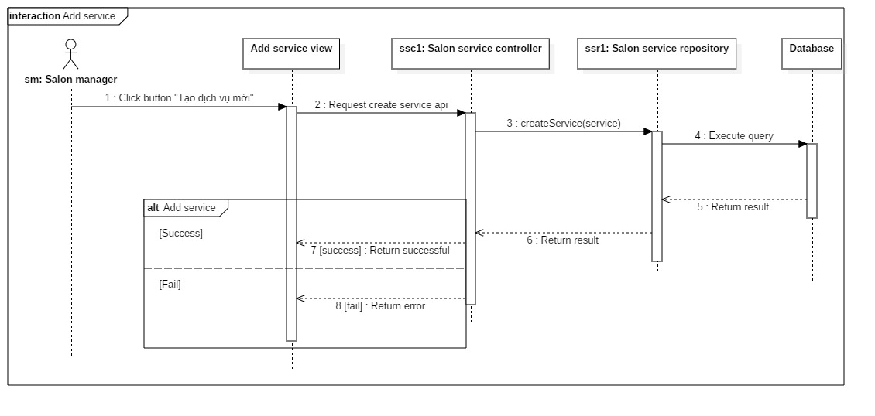

Figure 30 Sequence Diagram – Add service

#### Edit service

Summary:

* This diagram shows process of salon manager edit service

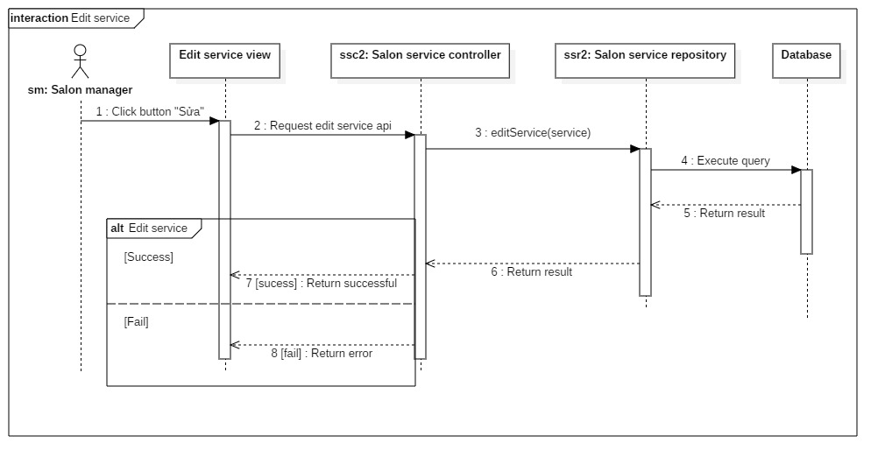

Figure 31 Sequence Diagram – Edit service

#### Delete service

Summary:

* This diagram shows the process of Salon manager delete a service

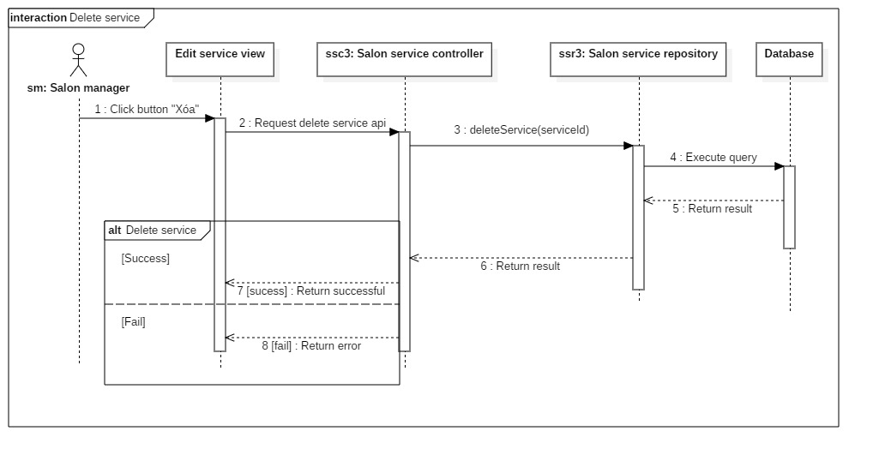

Figure 32 Sequence Diagram – Delete service

#### Cancel booking

Summary:

* This diagram shows the process of Salon manager cancel a booking.

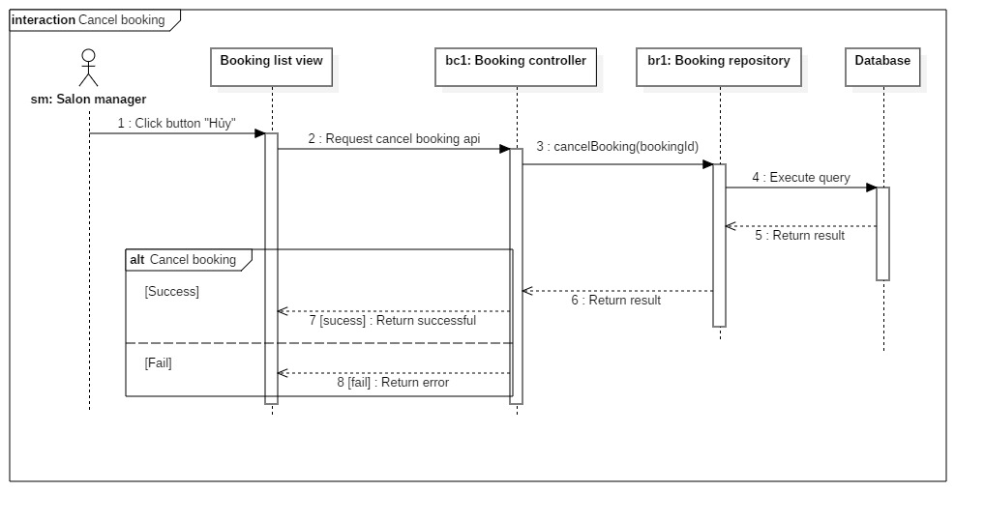

Figure 33 Sequence Diagram – Cancel booking

#### Finish booking

Summary:

* This diagram shows the process of Contractor request an equipment of a supplier

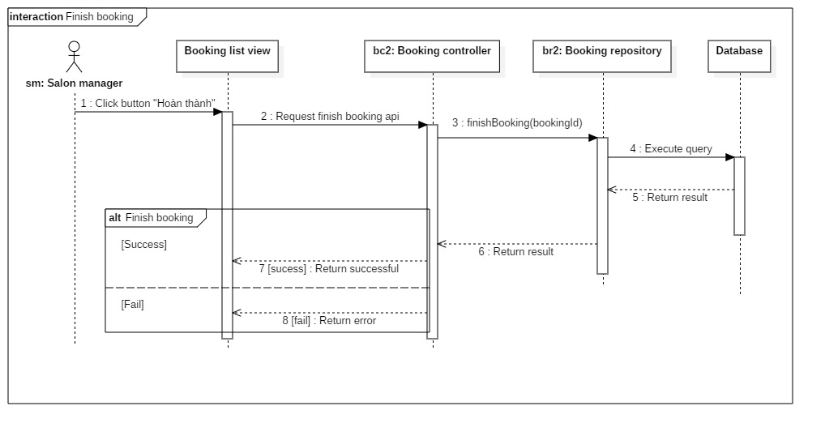

Figure 34 Sequence Diagram – Finish booking

#### Active customer

Summary:

* This diagram shows the process of Admin active a customer account

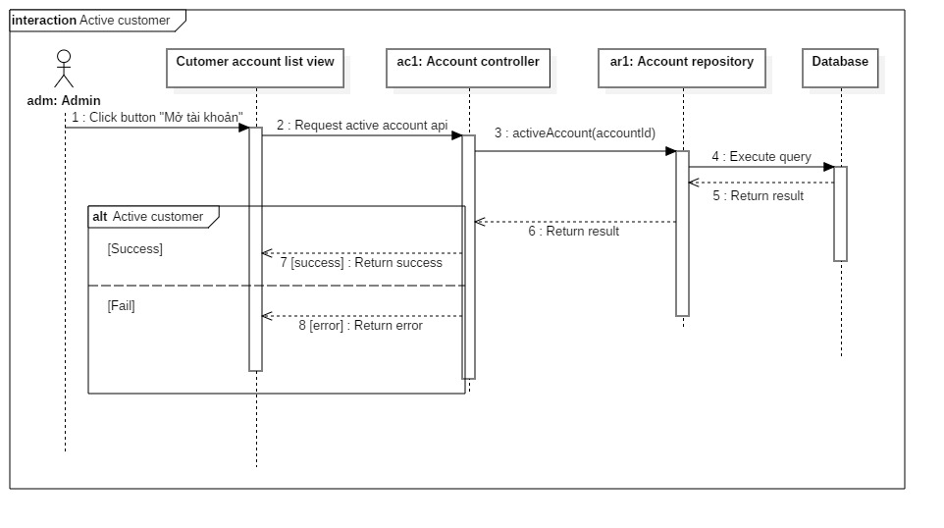

Figure 35 Sequence Diagram – Activate customer

#### Deactivate customer

Summary:

* This diagram shows the process of Admin deactivate a customer account

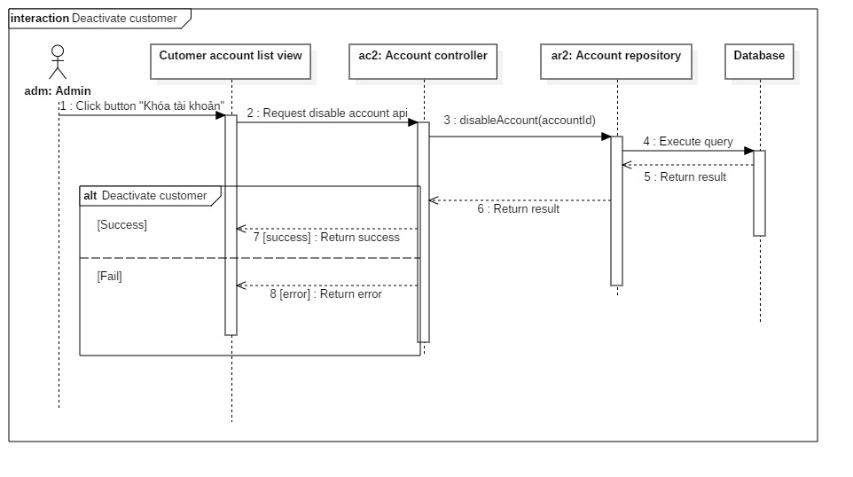

Figure 36 Sequence Diagram – Deactivate customer

#### Active salon

Summary:

* This diagram shows the process of Admin active a salon



Figure 37 Sequence Diagram –Activate salon

#### Deactivate salon

Summary:

* This diagram shows the process of Admin deactivate a salon



Figure 38 Sequence Diagram – Deactivate salon

### Activity Diagram

#### Login

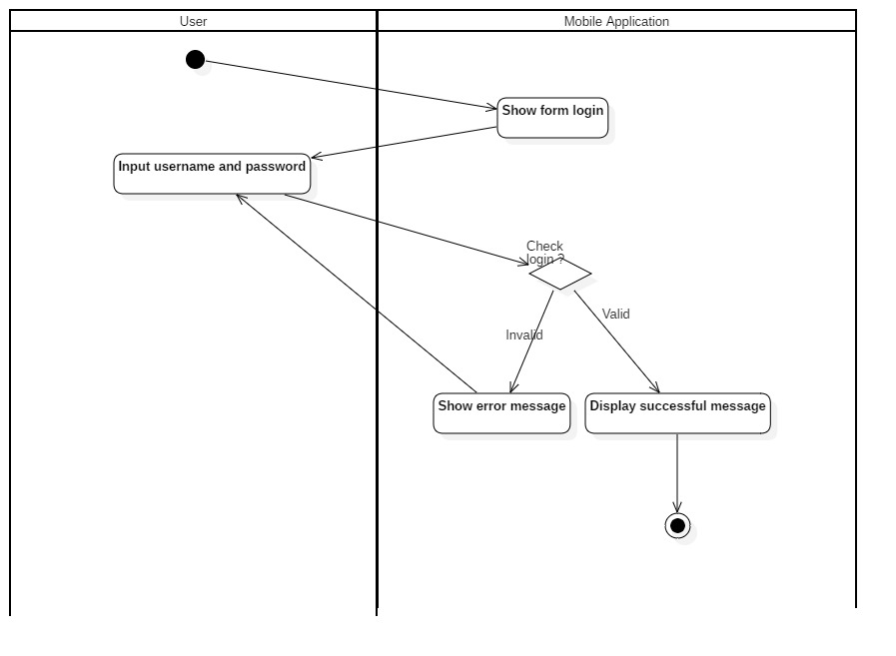

Figure 39 <Activity Diagram> Login

#### Register

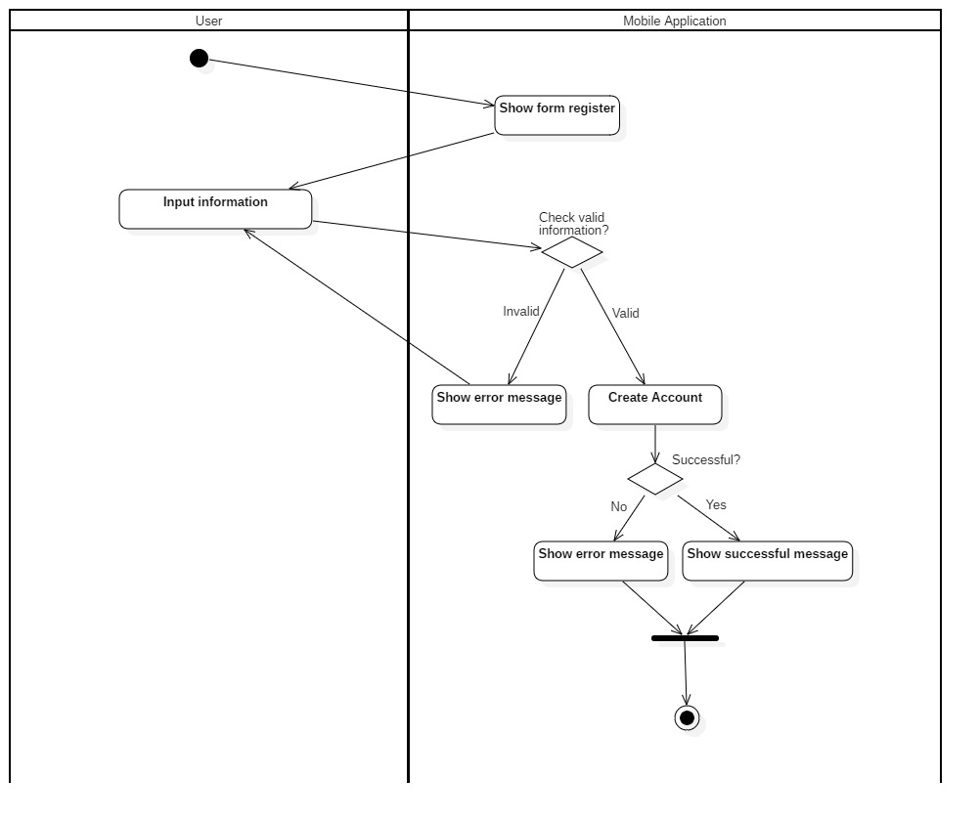

Figure 40 <Activity Diagram> Register

#### Find service

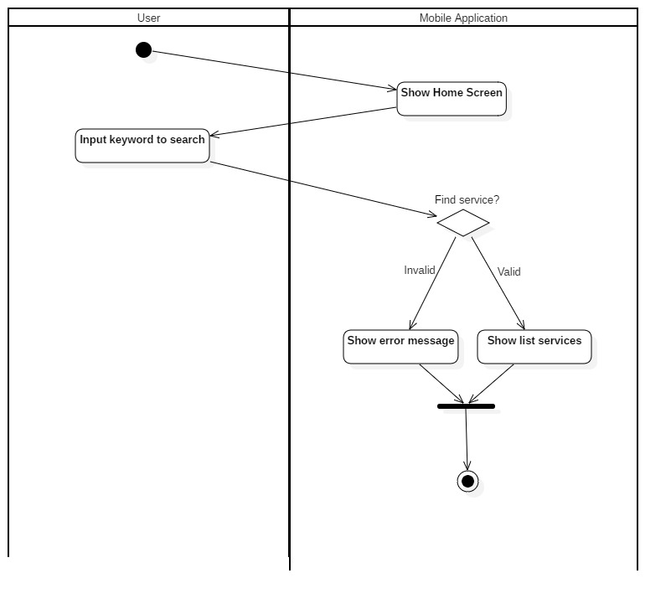

Figure 41 <Activity Diagram> Find service

#### Book service

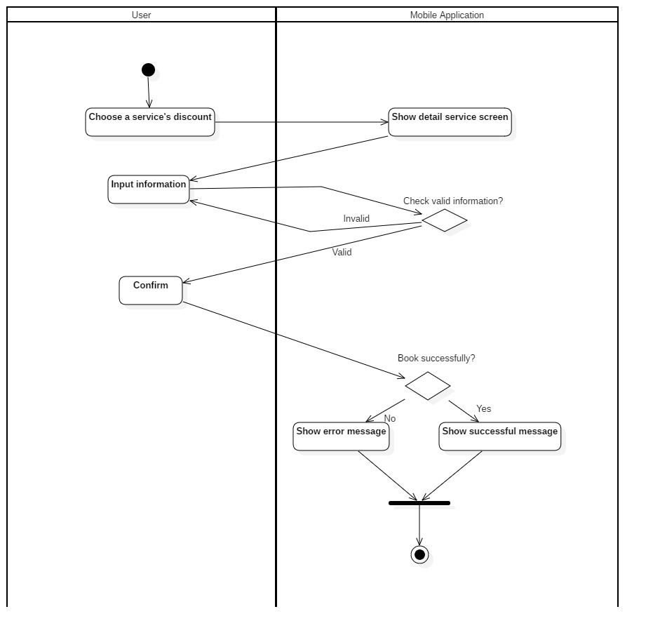

Figure 42 <Activity Diagram> Book services

#### View booking history

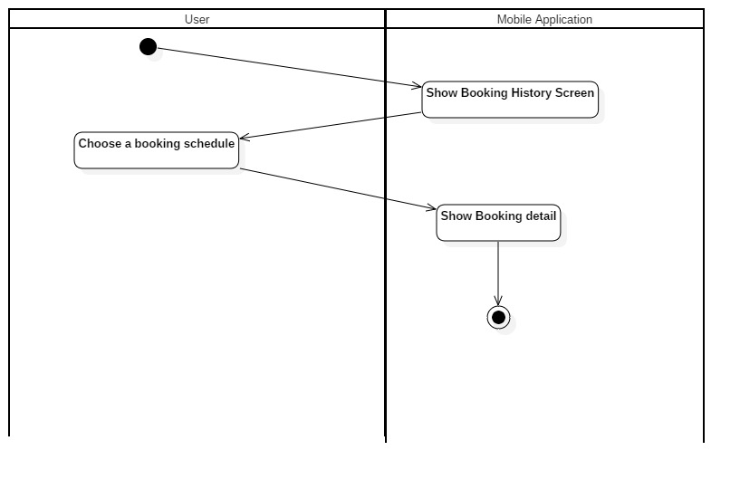

Figure 43 <Activity Diagram> View booking history

#### Cancel Booking

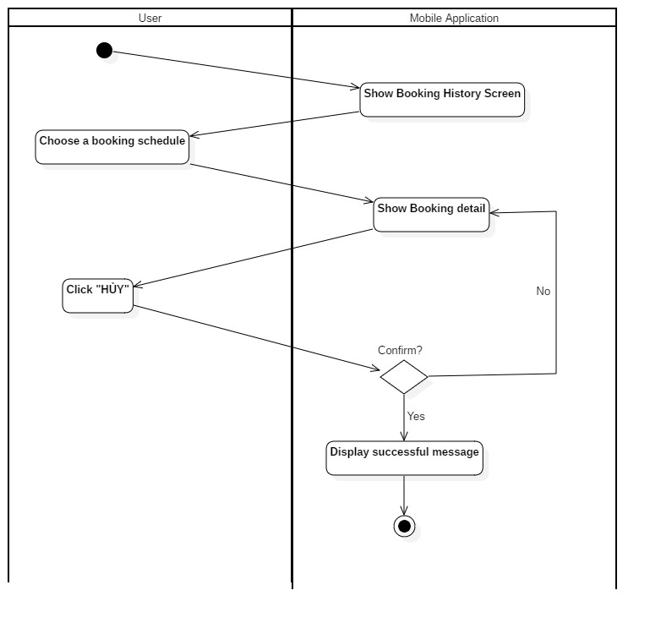

Figure 44 Cancel booking

## Interface

### Component Interface

Component Interface are Web Service API which will be used by Mobile Application and Web admin.

| **Signature** | **Description** | **Input** | **Output** | **Output Format** |
| --- | --- | --- | --- | --- |
| getAllSalonServiceSortByDV() | Get all salon service and sort by discount value | N/A | Json list object | Json |
| getAllUser() | Get list of use account | N/A | Json list object | Json |
| findById(id) | Find user account with id | Id:int | Json list object | Json |
| createAccount(account) | Create new account | Account:  Object | Json list object | Json |
| updateAccount(id, account) | Update account infomation | id: String  account:  Object | Json list object | Json |
| getAllBooking() | Get all booking | N/A | Json list object | Json |
| createBooking(bookingDTO) | Create new booking | bookingDTO:  Object | Json list object | Json |
| getAllHistoryByAccount(accountID) | Get all booking of user account | accountID:int | Json list object | Json |
| findBookingById(id) | Find booking by id | Id:int | Json list object | Json |
| cancelBooking(id) | Cancel a booking | Id:int | Json list object | Json |
| finishBooking(id) | Finish a booking | Id: int | Json list object | Json |
| getBookingBySalonId(salonId) | Get all booking of a salon | Id:int | Json list object | Json |
| getAllBookingDetail() | Get all booking detail | N/A | Json list object | Json |
| getBookingDetailsBySalonId  (id) | Get all booking detail by salon id | Id: int | Json list object | Json |
| searchSalon  (salonName) | Search salon by name | salonName:String | Json list object | Json |
| findSalonById  (id) | Find salon by id | Id: int | Json list object | Json |
| getSalonByManager  (id) | Find salon by manager account id | Id:int | Json list object | Json |
| findSalonServiceBySalonId  (id) | Find salon service by salon id | Id:int | Json list object | Json |
| searchSalonService  (searchValue) | Search salon service by service name | searchValue:  String | Json list object | Json |
| updateSalonService  (salonService) | Update salon service | salonService:  Object | Json list object | Json |
| disableSalonService  (salonServiceID) | Disable a service | salonServiceId:int | Json list object | Json |
| findAllSalonServiceByManager(managerId) | Find all salon service by manager account id | Manager id:int | Json list object | Json |
| createSalonService  (salonServiceDTO) | Create new salon service | salonServiceDTO:Object | Json list object | Json |
| createService  (service) | Create new service | Service:Object | Json list object | Json |

Table 28 Component Interface

### User Interface Design

#### Mobile Application

##### Login

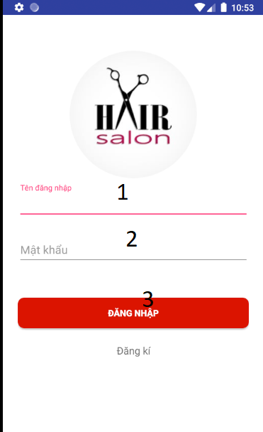

Figure 45 <UI Design> Login

**Fields**

|  |  |  |  |  |  |  |
| --- | --- | --- | --- | --- | --- | --- |
| **No** | **Field Name** | **Description** | **Read only** | **Mandatory** | **Control Type** | **Data Type** |
| 1 | Username | Username to login | No | Yes | Edit Text | String |
| 2 | Password | Password to login | No | Yes | Edit Text | String |

Table 29 <UI Design> Login fields

**Buttons/Hyperlinks:**

|  |  |  |  |  |
| --- | --- | --- | --- | --- |
| **No** | **Function** | **Description** | **Validation** | **Outcome** |
| 3 | Login | Login into the system | Required | User logged in into the system |

Table 30 <UI Design> Login Buttons

##### Register

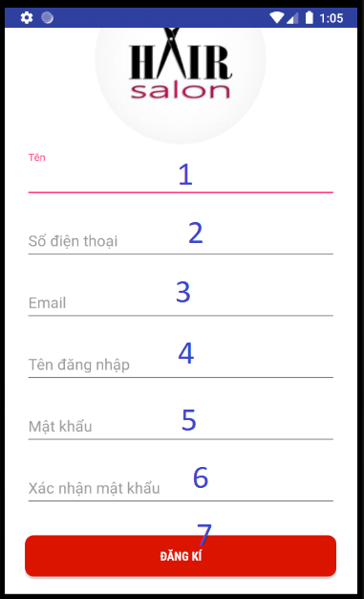

Figure 46 <UI Design> Register

**Fields**

|  |  |  |  |  |  |  |
| --- | --- | --- | --- | --- | --- | --- |
| **No** | **Field Name** | **Description** | **Read only** | **Mandatory** | **Control Type** | **Data Type** |
| 1 | Name | Name of user | No | Yes | Edit Text | String |
| 2 | Phone number | Phone number of user | No | Yes | Edit Text | String |
| 3 | Email | Email to sign up | No | Yes | Edit Text | String |
| 4 | Username | Username to sign up | No | Yes | Edit Text | String |
| 5 | Password | Password to sign up | No | Yes | Edit Text | String |
| 6 | Confirm password | Confirm password to sign up | No | Yes | Edit Text | String |

Table 31 <UI Design> Login fields

**Buttons/Hyperlinks:**

|  |  |  |  |  |
| --- | --- | --- | --- | --- |
| **No** | **Function** | **Description** | **Validation** | **Outcome** |
| 7 | Sign Up | User sign up new account | Required | User signed up new account successfully |

Table 32 <UI Design> Login buttons

##### Home screen

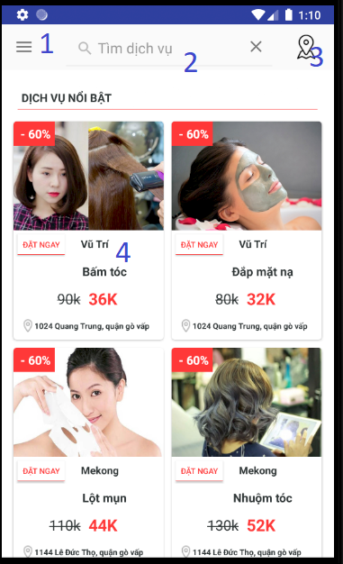

Figure 47 <UI Design> Home screen

**Buttons/Hyperlinks:**

|  |  |  |  |  |
| --- | --- | --- | --- | --- |
| **No** | **Function** | **Description** | **Validation** | **Outcome** |
| 1 | Menu | Menu icon | N/A | Show navigation menu |
| 2 | Search service | Search service by name | N/A | Enter keyword and then show list services |
| 3 | Search nearby salon | Search salon by location | N/A | Show nearby salon |
| 4 | Discount services | List of discount service | N/A | Redirect to service’s detail screen |

Table 33 <UI Design> Home screen buttons

##### Service detail screen

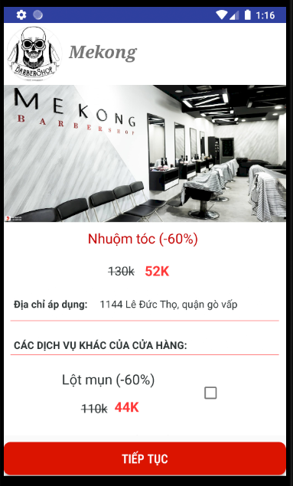

Figure 48 <UI Design> Service detail screen

##### Booking history screen

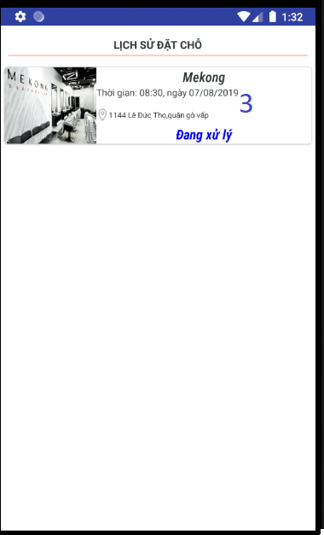

Figure 49 <UI Design> Booking history screen

##### Find salon by location

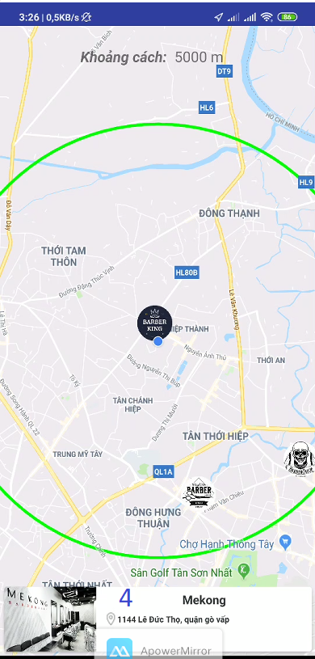

Figure 50 <UI Design> Find salons by location screen

##### Find service

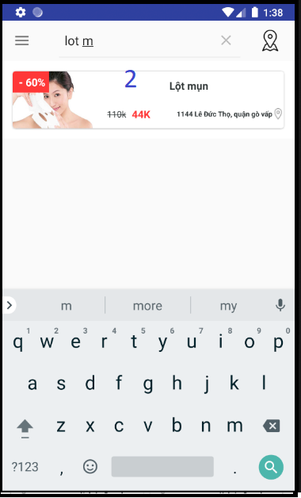

Figure 51 <UI Design> Find services screen

#### Web admin application

##### Login

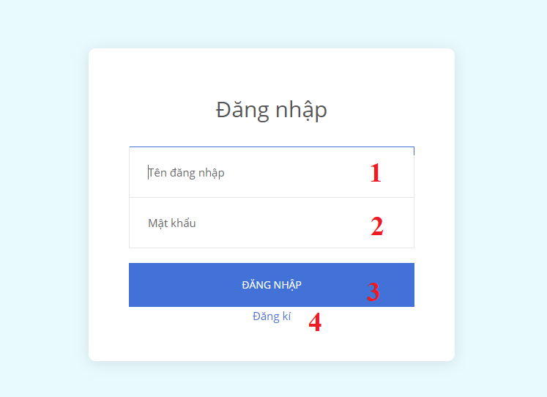

Figure 52 <UI Design> Login screen

**Fields**

|  |  |  |  |  |  |  |
| --- | --- | --- | --- | --- | --- | --- |
| **No** | **Field Name** | **Description** | **Read only** | **Mandatory** | **Control Type** | **Data Type** |
| 1 | Tên đăng nhập | Username to login | No | Yes | Text Box | String |
| 2 | Mật khẩu | Password to login | No | Yes | Text Box | String |

Table 34 <UI Design> Login fields

**Buttons/Hyperlinks:**

|  |  |  |  |  |
| --- | --- | --- | --- | --- |
| **No** | **Function** | **Description** | **Validation** | **Outcome** |
| 3 | Đăng nhập | Login into the system | Required | User logged in into the system |
| 4 | Đăng ký | Sign up new account | N/A | Redirect to sign up page |

Table 35 <UI Design> Login buttons

##### List service page

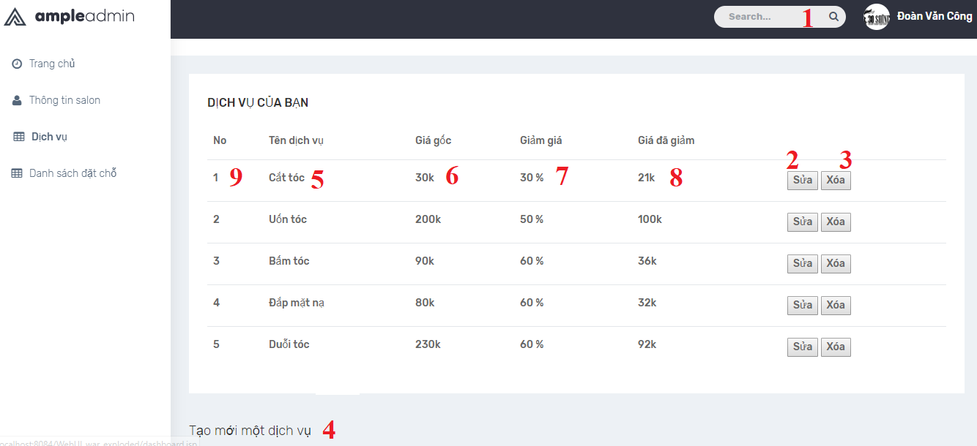

Figure 53 <UI Design> List services screen

**Fields**

|  |  |  |  |  |  |  |
| --- | --- | --- | --- | --- | --- | --- |
| **No** | **Field Name** | **Description** | **Read only** | **Mandatory** | **Control Type** | **Data Type** |
| 9 | No | Id of service | Yes | Yes | Text View | String |
| 5 | Tên dịch vụ | Service name | Yes | Yes | Text View | String |
| 6 | Giá gốc | Service’s real price | Yes | Yes | Text View | String |
| 7 | Giảm giá | Sale percent | Yes | Yes | Text View | String |
| 8 | Giá đã giảm | Sale price | Yes | Yes | Text View | String |
| 3 | Search | Search for service | No | Yes | Text View | String |

Table 36 <UI Design> List services screen fields

**Buttons/Hyperlinks:**

|  |  |  |  |  |
| --- | --- | --- | --- | --- |
| **No** | **Function** | **Description** | **Validation** | **Outcome** |
| 2 | Sửa | Edit service | N/A | Redirect user to edit service page |
| 3 | Xóa | Delete service | N/A | Delete corresponding service |
| 4 | Tạo mới dịch vụ | Create new service | N/A | Redirect user to create service page |

Table 37 <UI Design> List services screen buttons

##### List booking schedules page

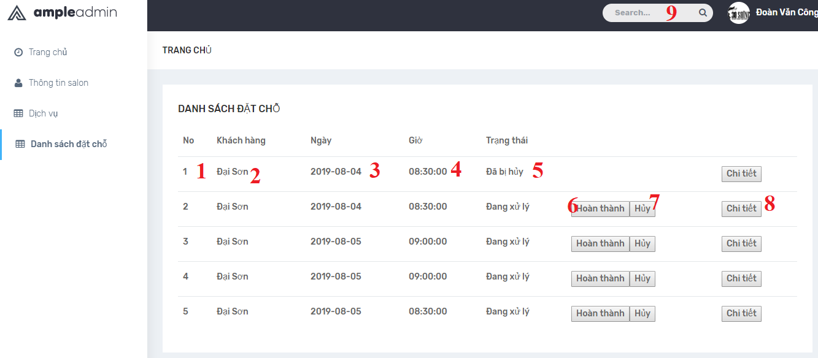

Figure 54 <UI Design> List Booking schedules screen

**Fields**

|  |  |  |  |  |  |  |
| --- | --- | --- | --- | --- | --- | --- |
| **No** | **Field Name** | **Description** | **Read only** | **Mandatory** | **Control Type** | **Data Type** |
| 1 | No | Id of booking | Yes | Yes | Text View | String |
| 2 | Khách hàng | Customer name | Yes | Yes | Text View | String |
| 3 | Ngày | Booking date | Yes | Yes | Text View | String |
| 4 | Giờ | Booking time | Yes | Yes | Text View | String |
| 5 | Trạng thái | Status of corresponding booking | Yes | Yes | Text View | String |
| 9 | Search | Search for booking | No | Yes | Text View | String |

Table 38 <UI Design>List Booking schedules screen fields

**Buttons/Hyperlinks:**

|  |  |  |  |  |
| --- | --- | --- | --- | --- |
| **No** | **Function** | **Description** | **Validation** | **Outcome** |
| 6 | Sửa | Edit service | N/A | Redirect user to edit service page |
| 7 | Xóa | Delete service | N/A | Delete corresponding service |
| 8 | Tạo mới dịch vụ | Create new service | N/A | Redirect user to create service page |

Table 39 <UI Design>List Booking schedules screen buttons

##### Salon information

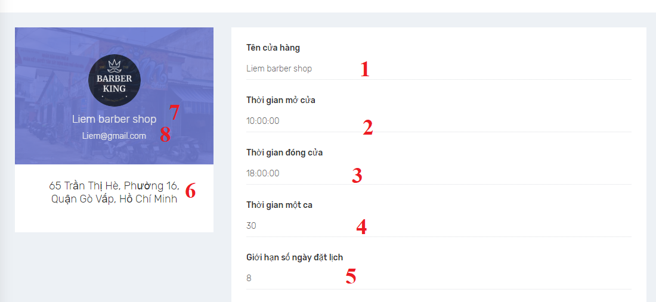

Figure 55 <UI Design> Salon information screen

**Fields**

|  |  |  |  |  |  |  |
| --- | --- | --- | --- | --- | --- | --- |
| **No** | **Field Name** | **Description** | **Read only** | **Mandatory** | **Control Type** | **Data Type** |
| 1 | Tên cửa hàng | Salon name | Yes | Yes | Text View | String |
| 2 | Thời gian mở cửa | Salon open time | Yes | Yes | Text View | String |
| 3 | Thời gian đóng cửa | Salon close time | Yes | Yes | Text View | String |
| 4 | Thời gian 1 ca | Slot time | Yes | Yes | Text View | String |
| 5 | Giới hạn số ngày đặt lịch | Booking day | Yes | Yes | Text View | String |
| 6 | Địa chỉ | Salon address | Yes | Yes | Text View | String |
| 7 | Email | Salon email | Yes | Yes | Text View | String |
| 8 | Tên cửa hàng | Salon name | Yes | Yes | Text View | String |

Table 40 <UI Design> Salon information screen fields

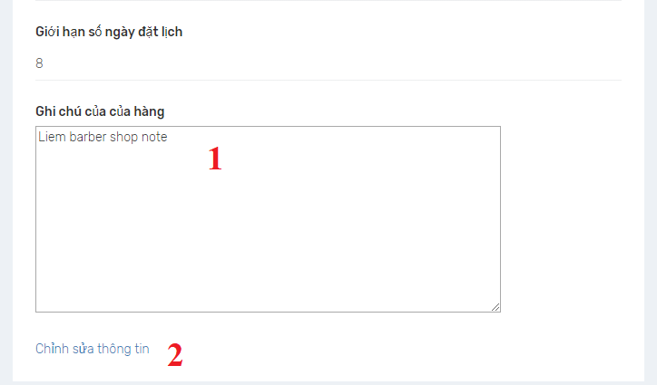

Figure 56 <UI Design> Salon information screen

**Fields**

|  |  |  |  |  |  |  |
| --- | --- | --- | --- | --- | --- | --- |
| **No** | **Field Name** | **Description** | **Read only** | **Mandatory** | **Control Type** | **Data Type** |
| 1 | Ghi chú của cửa hàng | Salon description | Yes | Yes | Text View | String |

Table 41 <UI Design> Salon information screen fields

**Buttons/Hyperlinks:**

|  |  |  |  |  |
| --- | --- | --- | --- | --- |
| **No** | **Function** | **Description** | **Validation** | **Outcome** |
| 2 | Chỉnh sửa thông tin | Edit salon infomation | N/A | Redirect user to edit salon infomation page |

Table 42 <UI Design> Salon information screen buttons

##### Update Salon

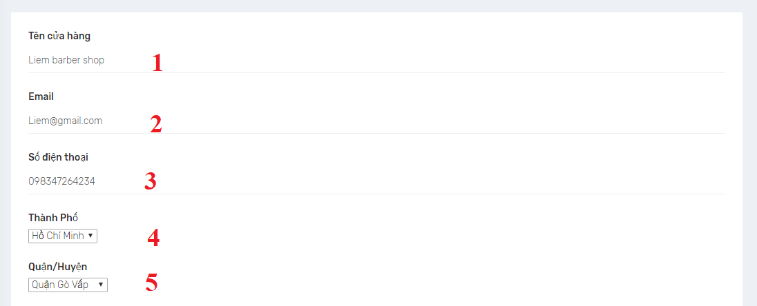

Figure 57 <UI Design> Update Salon screen

**Fields**

|  |  |  |  |  |  |  |
| --- | --- | --- | --- | --- | --- | --- |
| **No** | **Field Name** | **Description** | **Read only** | **Mandatory** | **Control Type** | **Data Type** |
| 1 | Tên cửa hàng | Salon name | No | Yes | Text View | String |
| 2 | Email | Salon email | No | Yes | Text View | String |
| 3 | Số điện thoại | Salon phone | No | Yes | Text View | String |
| 4 | Thành phố | Salon’s city | No | Yes | Drop down box | String |
| 5 | Quận/ Huyện | Salon’s district | No | Yes | Drop down box | String |

Table 43 <UI Design> Update Salon screen fields

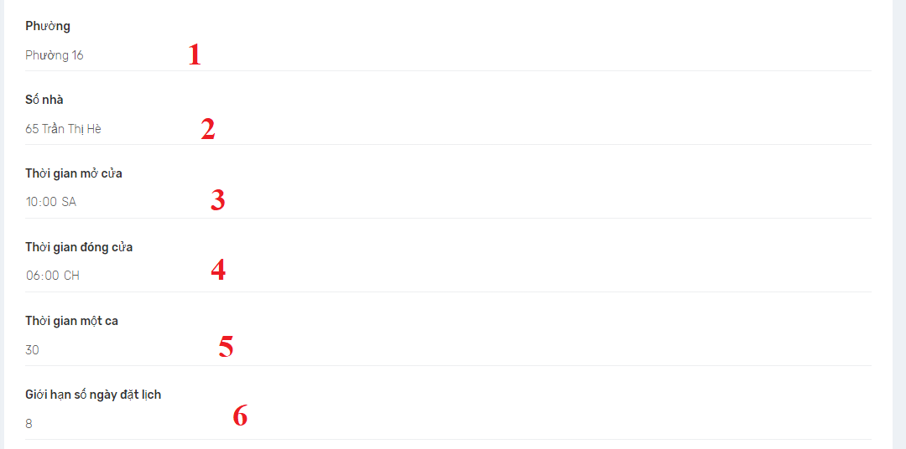

Figure 58 <UI Design> Update Salon screen

**Fields**

|  |  |  |  |  |  |  |
| --- | --- | --- | --- | --- | --- | --- |
| **No** | **Field Name** | **Description** | **Read only** | **Mandatory** | **Control Type** | **Data Type** |
| 1 | Phường | Salon street | No | Yes | Text View | String |
| 2 | Số nhà | Salon street number | No | Yes | Text View | String |
| 3 | Thời gian mở cửa | Salon open time | Yes | Yes | Text View | String |
| 4 | Thời gian đóng cửa | Salon close time | Yes | Yes | Text View | String |
| 5 | Thời gian 1 ca | Slot time | Yes | Yes | Text View | String |
| 6 | Giới hạn số ngày đặt lịch | Booking day | Yes | Yes | Text View | String |

Table 44 <UI Design> Update Salon screen fields

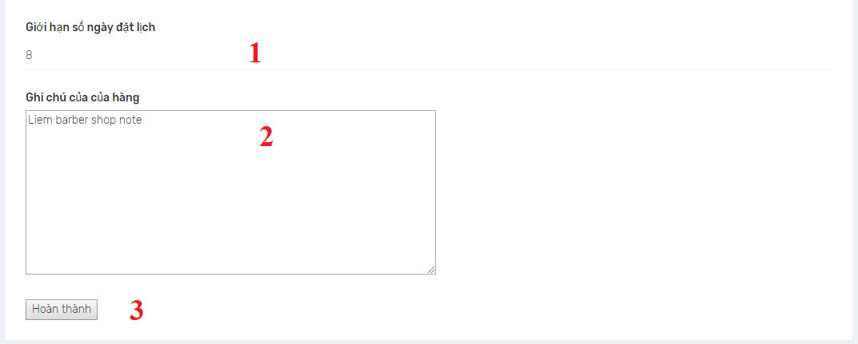

Figure 59 <UI Design> Update Salon screen

**Fields**

|  |  |  |  |  |  |  |
| --- | --- | --- | --- | --- | --- | --- |
| **No** | **Field Name** | **Description** | **Read only** | **Mandatory** | **Control Type** | **Data Type** |
| 1 | Giới hạn số ngày đặt lịch | Booking day | No | Yes | Text View | String |
| 2 | Ghi chú của cửa hàng | Salon description | No | Yes | Text View | String |

Table 45 <UI Design> Update Salon screen fields

**Buttons/Hyperlinks:**

|  |  |  |  |  |
| --- | --- | --- | --- | --- |
| **No** | **Function** | **Description** | **Validation** | **Outcome** |
| 6 | Hoàn thành | Submit change | All field must be valid before insert to database | Update change to salon information. |

Table 46 <UI Design> Update Salon screen buttons

##### Create Service

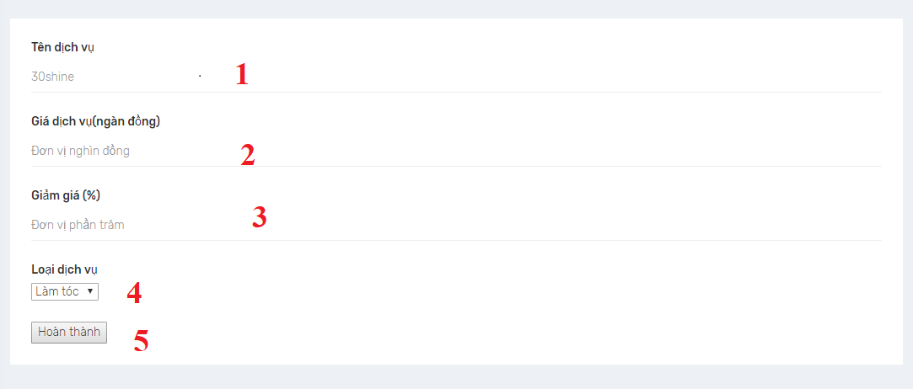

Figure 60 <UI Design> Create service screen

**Fields**

|  |  |  |  |  |  |  |
| --- | --- | --- | --- | --- | --- | --- |
| **No** | **Field Name** | **Description** | **Read only** | **Mandatory** | **Control Type** | **Data Type** |
| 1 | Tên dịch vụ | Service name | No | Yes | Text View | String |
| 2 | Giá dịch vụ | Service price | No | Yes | Text View | String |
| 3 | Giảm giá | Discount value | No | Yes | Text View | String |
| 4 | Loại dịch vụ | Service category | No | Yes | Drop down box | String |

Table 47 Create service screen fields

**Buttons/Hyperlinks:**

|  |  |  |  |  |
| --- | --- | --- | --- | --- |
| **No** | **Function** | **Description** | **Validation** | **Outcome** |
| 6 | Hoàn thành | Submit change | All field must be valid before insert to database | Create new service |

Table 48 Create service screen buttons

## Database Design

### Entity Relationship Diagram (ERD)

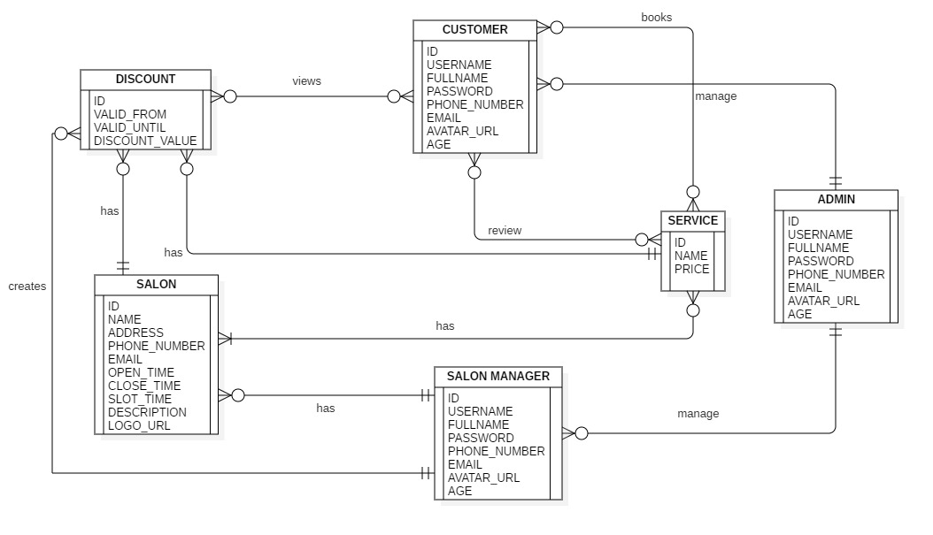

Figure 61 Entity Relation Diagram

### Data Dictionary

|  |  |
| --- | --- |
| Entity Data Dictionary: describe content of all entities | |
| **Entity Name** | **Description** |
| Discount | Contain discount information |
| Salon | Contain salon information |
| Customer | Contain customer information |
| Salon manager | Contain salon manager profile information |
| Service | Contain service information |
| Admin | Contain admin information |

Table 49 Entity Relationship Diagram Dictionary

#### Discount

|  |  |  |  |
| --- | --- | --- | --- |
| **Attribute** | **Type** | **Visibility** | **Description** |
| Id | Integer | Private | Unique identifier of discount |
| Valid_from | Date time | Private | Discount start date |
| Valid_until | Date time | Private | Discount end date |
| Discount_value | Integer | Private | Value of discount |

Table 50 Entity Relationship Diagram Dictionary-Discount

#### Salon

|  |  |  |  |
| --- | --- | --- | --- |
| **Attribute** | **Type** | **Visibility** | **Description** |
| Id | Integer | Private | Unique identifier of a salon. |
| Name | String | Private | Name of salon |
| Address | String | Private | Address of salon |
| Phone number | String | Private | Phone number of salon |
| Email | String | Private | Email of salon |
| Open time | Datetime | Private | The open time of salon |
| Close time | Datetime | Private | The close time of salon |
| Slot time | Datetime | Private | Time for each slot of salon |

Table 51 Entity Relationship Diagram Dictionary-Salon

#### Customer

|  |  |  |  |
| --- | --- | --- | --- |
| **Attribute** | **Type** | **Visibility** | **Description** |
| Id | Integer | Private | Unique identifier of a customer |
| User name | String | Private | Customer name |
| Full name | String | Private | Full name of customer |
| Password | String | Private | Password of customer account |
| Phone number | String | Private | Phone number of customer |
| Email | String | Private | Email of customer |
| Avatar url | String | Private | Avatar link of customer |

Table 52 Entity Relationship Diagram Dictionary- Customer

#### Salon Manager

|  |  |  |  |
| --- | --- | --- | --- |
| **Attribute** | **Type** | **Visibility** | **Description** |
| Id | Integer | Private | Unique identifier of a salon manager |
| User name | String | Private | Salon manager name |
| Full name | String | Private | Full name of salon manager |
| Password | String | Private | Password of salon manager account |
| Phone number | String | Private | Phone number of salon manager |
| Email | String | Private | Email of salon manager |
| Avatar url | String | Private | Avatar link of salon manager |

Table 53 Entity Relationship Diagram Dictionary- Salon manager

#### Admin

|  |  |  |  |
| --- | --- | --- | --- |
| **Attribute** | **Type** | **Visibility** | **Description** |
| Id | Integer | Private | Unique identifier of a admin |
| User name | String | Private | Admin name |
| Full name | String | Private | Full name of admin |
| Password | String | Private | Password of admin account |
| Phone number | String | Private | Phone number of admin |
| Email | String | Private | Email of admin |
| Avatar url | String | Private | Avatar link of admin |

Table 54 Entity Relationship Diagram Dictionary- Admin

#### Service

|  |  |  |  |
| --- | --- | --- | --- |
| **Attribute** | **Type** | **Visibility** | **Description** |
| Id | Integer | Private | Unique identifier of a admin |
| Name | String | Private | Service name |
| Price | String | Private | Service price |

Table 55 Entity Relationship Diagram Dictionary- Service

## Algorithms

### Find best salon

#### Definition

Find best salon algorithm is a method that helps customer to find a best salon based on discount, location and review.

#### Problem

Many customers want to find a good salon but they are confused because there are so many salon with different kind of service.

#### Solution

Find best salon including the following step

* User select priority for average disount, rating and distance. Priority has 3 level: high, medium and low. High is 3 point, medium is 2 point and low is 1 point
* Get list of all salon
* Sort list of salon by average discount and set average discount point by sort order, do the same thing with distance and rating
* Caculate total point for each salon by the following fomula:

Salon total point = average discount point * priority of average discount + distance point * priority point of distance + rating point * priority of rating

* Sort salon list by total point and show three best salon

#### Example

|  |  |  |  |
| --- | --- | --- | --- |
| **Salon name** | **Average discount(%)** | **Rating(star)** | **Distance(m)** |
| A | 60 | 3.4 | 2000 |
| B | 23 | 2.3 | 5000 |
| C | 70 | 5 | 1000 |
| D | 10 | 4.5 | 3500 |

For example, user select priority input is: High for average discount, high for rating and low for distance, so priority point for average discount is 3, rating is 3 and distance is 1.

After sort list of salon and set point by sort order

|  |  |  |  |
| --- | --- | --- | --- |
| **Salon name** | **Average discount point** | **Rating point** | **Distance point** |
| A | 3 | 2 | 3 |
| B | 2 | 1 | 1 |
| C | 4 | 4 | 4 |
| D | 1 | 3 | 2 |

Caculate total point for each salon with formula:

Average discount point * priority of average discount + distance point * priority point of distance + rating point * priority of rating

|  |  |
| --- | --- |
| **Salon name** | **Total point** |
| A | 3x3 + 2x3 + 3x1 = 18 |
| B | 2x3 + 1x3 + 1x1 = 10 |
| C | 4x3 + 4x3 + 4x1 = 28 |
| D | 1x3 + 3x3 + 2x1 = 14 |

Three best salon is C , A, D

#### Complexity

In total, the complexity of this algorithm is O(n).

#### Flow chart

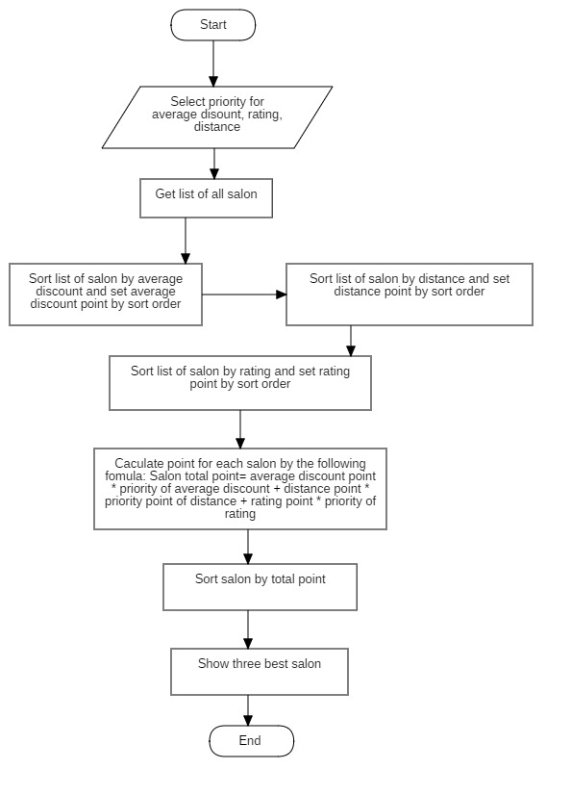

Figure 62 Algorithms

# System implementation & Test

## Introduction

### Overview

This section provides in detail all necessary information about implementation information and testing procedure of HSB system includes test plans, test cases, test result and risks estimations.

### Test Approach

* Goal: To test the whole system based on the core workflow.
* Method: System Testing

## Database Relationship Diagram

### Physical Diagram

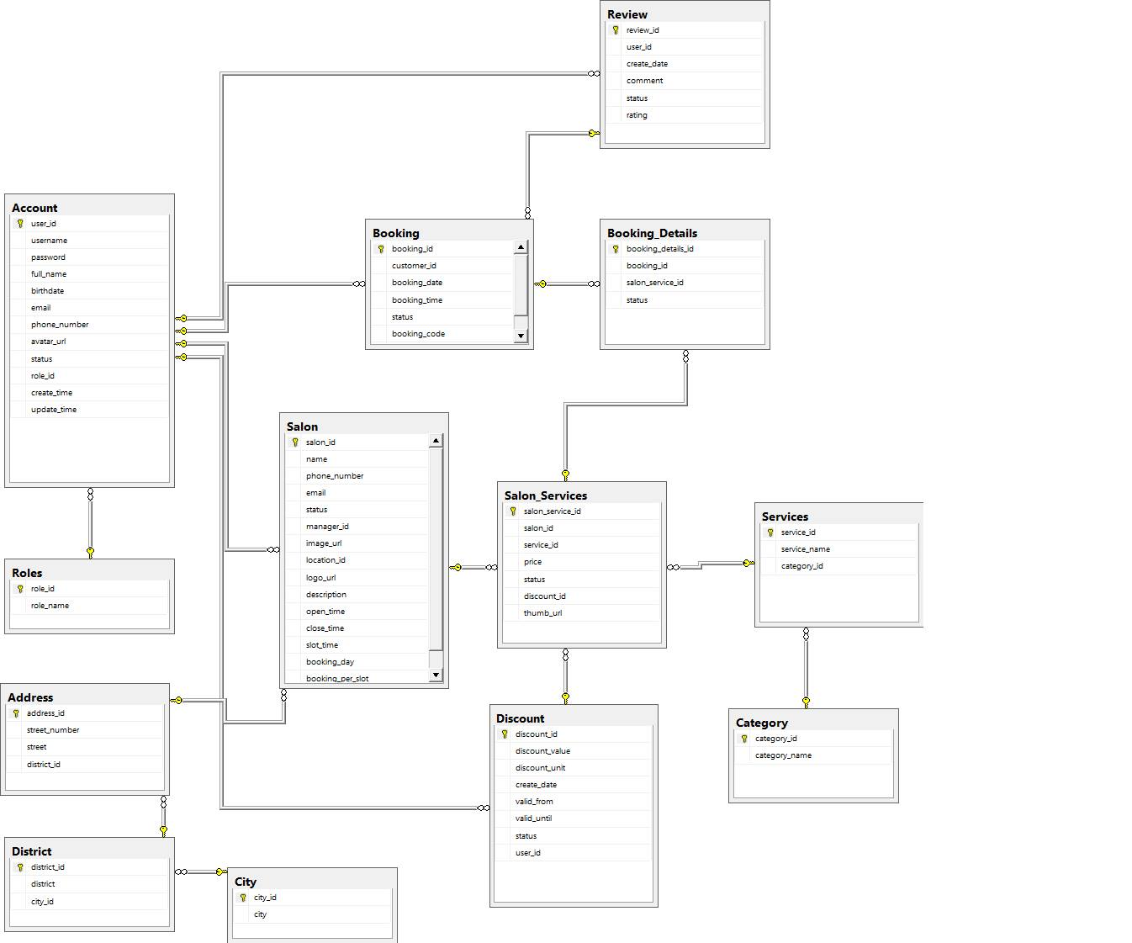

Figure 63: Physical Diagram

### Data dictionary

|  |  |
| --- | --- |
| **Data dictionary: describe content of all tables** | |
| **Entity name** | **Description** |
| Account | Describe account infomation |
| Role | Describe different role of an account |
| Address | Describe address of a salon |
| District | Describe distric of an address. |
| City | Describe city of a district |
| Salon | Describe information of a salon |
| Booking | Describe booking of a custommer |
| Booking detail | Describe detail of a booking |
| Review | Describe review of a booking |
| Salon service | Describe information of a salon service |
| Service | Describe information of service |
| Discount | Describe discount of a service |
| Category | Describe category of a service |

Table 56 Database Data Dictionary

## Test Plan

The purpose of this section is to verify and ensure that HSB system meets its design specification and other requirements from user. The following part will describe which features to be tested and which will not.

### Features to be tested

* Mobile app:
  + Search service
  + Find nearby salon
  + Book service
  + Register user
  + User login
  + View booking history
  + Cancel booking
  + Get direction to salon
* Web app
  + Login
  + Register salon

### Features not to be tested

## System Testing Test Case

### Mobile app testing case:

#### 4.1.1. <Guest> Login

|  |  |  |  |  |  |  |  |
| --- | --- | --- | --- | --- | --- | --- | --- |
| **ID** | **Test case description** | **Test case procedure** | **Expected output** | **Inter-dependence test case** | **Result** | **Test date** | **Note** |
| L_01 | Test guest log in successfully on mobile application | 1. Guest inputs correct username and password.  2. Guest clicks the button “Đăng nhập”. | Direct guest to “Home” screen and show message “ Đăng nhập thành công”. |  | Pass | 30/07/2019 |  |
| L_02 | Test guest enters wrong username or password | 1. Guest inputs wrong username or password.  2. Guest clicks the button “Đăng nhập”. | System shows error message “ Sai tên đăng nhập hoặc mật khẩu”. |  | Pass | 30/07/2019 |  |
| L_04 | Test guest left field “Tên đăng nhập” blank. | 1. Guest does not input in the field “Tên đăng nhập”.  2. Guest clicks the button “Đăng nhập”. | System shows error message “Nhập tên đăng nhập”. |  | Pass |  |  |
| L_05 | Test guest left field “Mật khẩu” blank. | 1. Guest  does not input in the field “Mật khẩu”.  2. Guest clicks the button “Đăng nhập”. | System shows error message “Nhập mật khẩu”. |  |  |  |  |

Table 57 <Test Case> Login

#### <Customer> Search service by service name

|  |  |  |  |  |  |  |  |
| --- | --- | --- | --- | --- | --- | --- | --- |
| **ID** | **Test case description** | **Test case procedure** | **Expected output** | **Inter-dependence test case** | **Result** | **Test date** | **Note** |
| TC_SS_01 | Test search succesfully on mobile application | User inputs service name in the search bar. | Displays all service corresponding to the inputed value on screen |  | Pass | 30/07/2019 |  |
| TC_SS_02 | Test user inputs unavailable service | User inputs unavailable service name in the search bar. | Display empty list on screen |  | Pass | 30/07/2019 |  |
| TC_SS_03 | Test user inputs nothing in search bar . | User inputs nothing in the search bar. | Display empty list on screen |  | Pass | 30/07/2019 |  |

Table 58 <Test Case> Find services

#### <Customer> Find nearby salon

|  |  |  |  |  |  |  |  |
| --- | --- | --- | --- | --- | --- | --- | --- |
| **ID** | **Test case description** | **Test case procedure** | **Expected output** | **Inter-dependence test case** | **Result** | **Test date** | **Note** |
| FNS_01 | Test find nearby salon succesfully on mobile application | User tap location icon | Displays all salon near user’s location on map. |  | Pass | 30/07/2019 |  |
| FNS_02 | Test user has not turned on location service. | User tap location icon | Display message on screen:  “Bạn muôn bật định vị không?”  - User select option” Có”: System turn on location service and show all nearby salon on map  - User select option” Không”:  Show home screen. |  | Pass | 30/07/2019 |  |

Table 59 <Test Case> Find Salons

#### <Customer> Find salon by rating

|  |  |  |  |  |  |  |  |
| --- | --- | --- | --- | --- | --- | --- | --- |
| **ID** | **Test case description** | **Test case procedure** | **Expected output** | **Inter-dependence test case** | **Result** | **Test date** | **Note** |
| TC_FSR_01 | Test search succesfully on mobile application | User is at home screen | Displays all service sorted by rating |  | Pass | 30/07/2019 |  |

#### <Customer> Book services

|  |  |  |  |  |  |  |  |
| --- | --- | --- | --- | --- | --- | --- | --- |
| **ID** | **Test case description** | **Test case procedure** | **Expected output** | **Inter-dependence test case** | **Result** | **Test date** | **Note** |
| BS_01 | Book service successfully | 1. User is logged in with role “Customer”  2. User is in home screen  3. User click on a service in home screen  4. User choose service, date and time  5. Click “Tiếp tục” button  6. Click “Xác nhận” button  7. Click “Hoàn tất đặt chỗ” button | Show successful message “Cảm ơn quý khách đã sử dụng dịch vụ” and go back to home screen |  | Pass | 04/08/2019 |  |
| BS_02 | Book service fail (Not login) | 1. User is not logged in  2. User is in home screen  3. User click on a service in home screen  4. User choose service, date and time  5. Click “Tiếp tục” button | Show error message “Hãy đăng nhập để tiếp dục đặt lịch” and redirect to Login screen |  | Pass | 04/08/2019 |  |
| BS_03 | Book service fail (Not choose service) | 1. User is logged in with role “Customer”  2. User is in home screen  3. User click on a service in home screen  4. Click “Tiếp tục” button | Show error message “Bạn chưa chọn dịch vụ!” |  | Pass | 04/08/2019 |  |
| BS_04 | Book service fail (Not choose date and time) | 1. User is logged in with role “Customer”  2. User is in home screen  3. User click on a service in home screen  4. User choose services  4. Click “Tiếp tục” button | Show error message “Bạn chưa chọn thời gian đến” |  | Pass | 04/08/2019 |  |

Table 60 <Test Case> Book services

#### <Customer> Cancel service

|  |  |  |  |  |  |  |  |
| --- | --- | --- | --- | --- | --- | --- | --- |
| **ID** | **Test case description** | **Test case procedure** | **Expected output** | **Inter-dependence test case** | **Result** | **Test date** | **Note** |
| CS_01 | Cancel service successfully | 1. User is logged in with role “Customer”  2. User is in home screen  3. User click on hamburger icon to open menu  4. User click on “Lịch sử đặt”  5. User click on a booking schedule  6. Click “HỦY” button  7. Click “CÓ” in alert dialog | Booking schedule is canceled successfully |  | Pass | 04/08/2019 |  |
| CS_02 | Cancel service fail | 1. User is logged in with role “Customer”  2. User is in home screen  3. User click on hamburger icon to open menu  4. User click on “Lịch sử đặt”  5. User click on a booking schedule  6. Click “HỦY” button  7. Click “KHÔNG” in alert dialog | Booking schedule is not canceled |  | Pass | 04/08/2019 |  |

Table 61 <Test Case> Cancel service

### Web app testing case

#### <Salon manager> Create service

|  |  |  |  |  |  |  |  |
| --- | --- | --- | --- | --- | --- | --- | --- |
| **ID** | **Test case description** | **Test case procedure** | **Expected output** | **Inter-dependence test case** | **Result** | **Test date** | **Note** |
| CS2_01 | Create service successfully | 1. User is logged in with role “Salon manager”  2. User is in List Services page  3. User click on hyper link “Tạo mới một dịch vụ”  4. User fill in all fields  5. User click “Tạo mới” button | Create service successfully |  | Pass | 04/08/2019 |  |

#### <Salon manager> Approve Booking schedule

|  |  |  |  |  |  |  |  |
| --- | --- | --- | --- | --- | --- | --- | --- |
| **ID** | **Test case description** | **Test case procedure** | **Expected output** | **Inter-dependence test case** | **Result** | **Test date** | **Note** |
| ABS_01 | Approve booking schedule successfully | 1. User is logged in with role “Salon manager”  2. User is in home screen  3. User click on “Danh sách đặt chỗ” on menu  4. User click on “Hoàn thành” button | Booking schedule is approved successful |  | Pass | 04/08/2019 |  |

Table 62 <Test Case> Approve Booking Schedule

#### <Salon manager> Cancel Booking schedule

|  |  |  |  |  |  |  |  |
| --- | --- | --- | --- | --- | --- | --- | --- |
| **ID** | **Test case description** | **Test case procedure** | **Expected output** | **Inter-dependence test case** | **Result** | **Test date** | **Note** |
| CBS_01 | Cancel booking schedule successfully | 1. User is logged in with role “Salon manager”  2. User is in home screen  3. User click on “Danh sách đặt chỗ” on menu  4. User click on “Hủy” button | Booking schedule is canceled successful |  | Pass | 04/08/2019 |  |

Table 63 <Test Case> Cancel Booking Schedule

#### <Admin > Activate Customer

|  |  |  |  |  |  |  |  |
| --- | --- | --- | --- | --- | --- | --- | --- |
| **ID** | **Test case description** | **Test case procedure** | **Expected output** | **Inter-dependence test case** | **Result** | **Test date** | **Note** |
| AC_01 | Activate Customer successfully | 1. User is logged in with role “Admin”  2. User is in List Customer page  4. User click on “Bỏ chặn” button | Activate Customer successfully |  | Pass | 04/08/2019 |  |

#### < Admin > Deactive Customer

|  |  |  |  |  |  |  |  |
| --- | --- | --- | --- | --- | --- | --- | --- |
| **ID** | **Test case description** | **Test case procedure** | **Expected output** | **Inter-dependence test case** | **Result** | **Test date** | **Note** |
| DC_01 | Deactivate Customer successfully | 1. User is logged in with role “Admin”  2. User is in List Customer page  4. User click on “Chặn” button | Deactivate Customer successfully |  | Pass | 04/08/2019 |  |

#### < Admin > Active Salon Manager

|  |  |  |  |  |  |  |  |
| --- | --- | --- | --- | --- | --- | --- | --- |
| **ID** | **Test case description** | **Test case procedure** | **Expected output** | **Inter-dependence test case** | **Result** | **Test date** | **Note** |
| ASM_01 | Activate Salon manager successfully | 1. User is logged in with role “Admin”  2. User is in List Salon manager page  4. User click on “Bỏ chặn” button | Deactivate Salon manager successfully |  | Pass | 04/08/2019 |  |

#### < Admin > Deactiver Salon manager

|  |  |  |  |  |  |  |  |
| --- | --- | --- | --- | --- | --- | --- | --- |
| **ID** | **Test case description** | **Test case procedure** | **Expected output** | **Inter-dependence test case** | **Result** | **Test date** | **Note** |
| DSM_01 | Deactivate Salon manager successfully | 1. User is logged in with role “Admin”  2. User is in List Salon manager page  4. User click on “Chặn” button | Deactivate Salon manager successfully |  | Pass | 04/08/2019 |  |

# Software User’s Manual

## Installation Guide

### Setting up environment at server

#### Hardware requirements

* **For Server**

|  |  |  |
| --- | --- | --- |
| **Server** | **Minimum Requirements** | **Recommended** |
| **Internet Connection** | Cable, Wi-Fi (8 Mbps) | Cable, Wi-Fi (50 Mbps or more) |
| **Operating System** | CentOS 6 | CentOS 7 or Ubuntu 18 |
| **Computer Processor** | Intel® Xeon ® 1.4GHz | Intel® Xeon ® Quad Core (12M Cache, 2.50 GHz) |
| **Computer Memory** | 2GB RAM | 8GB or more |
| **Storage space** | 3GB | 5GB or more |

Table 64 Hardware requirements for Server

* **For PC**

|  |  |  |
| --- | --- | --- |
| **PC** | **Minimum Requirements** | **Recommended** |
| **Internet Connection** | Cable, Wi-Fi (4 Mbps) | Cable, Wi-Fi (8 Mbps) |
| **Operating System** | Window 7 | Window 7 or more. |
| **Computer Processor** | Intel® Core i3 1.4GHz | Intel® Core i5 2.50GHz |
| **Computer Memory** | 1GB RAM | 2GB RAM or more |
| **Web Browser** | Chromes (v42 or higher) | Chrome latest stable version |

Table 65 Hardware requirements for PC

* **For Mobile**

|  |  |  |
| --- | --- | --- |
| **Mobile** | **Minimum Requirements** | **Recommended** |
| **Internet Connection** | Wi-Fi (4 Mbps) | Wi-Fi (8 Mbps) |
| **Operating System** | Android 6.0 | Android 7.1.1 |
| **Mobile Processor** | SnapDragon 625 | SnapDragon 625 |
| **Mobile Memory** | 2GB RAM | 4GB RAM or more |

Table 66 Hardware requirements for Mobile

#### Software requirement

|  |  |  |
| --- | --- | --- |
| **Name** | **Name/Version** | **Description** |
| **Environment** | Spring boot, Java Script 6 | Specification for developing web application |
| **Dependency manager, build tool** | Gradle 5.3.1, Maven 3.6.1 | Dependency managers, build tools for development |
| **Operating System** | Window 10 | Operating system and platform for development |
| **Modeling tool** | StarUML | Used to design diagram |
| **IDE** | IntelliJ IDEA 2018.1.5, Android studio | Programming tools |
| **DBMS** | SQL Server 2014 or SQL Server 2016 | Used to create & manage the database for development |
| **Web browser** | Chrome 69 or above. | Testing browser |
| **Mobile OS** | Android 5.1 or above | Testing mobile device operating system |
| **Deployment Server** | Docker Compose 1.24.0 or above | Deployment environment for production |

Table 65 Software requirements

### Deployment at server side

#### Prepare deployment package

* **Development**

Download and install Java  
Link download: <http://www.oracle.com/technetwork/java/javase/downloads/java-archive-javase8-2177648.html>

* + Download and install IntelliJ IDEA (Includes Gradle and Maven)  
    Link download:  
    [https://www.jetbrains.com/idea/download/#section=windows](https://www.jetbrains.com/idea/download/)
  + Download and install SQL Server 2014  
    Link download:  
    <https://www.microsoft.com/en-us/download/details.aspx?id=42299>
  + Download and install Android Studio   
    Link download:  
    [<https://developer.android.com/studio>](https://nodejs.org/en/download/)

#### Configure Server before deploy

* Development:
  + MSSQL 2014: create new database and new user and grant all privileges on the new database to the new user.
  + Web API application:
    - Copy capstone-ccp/client-api/src/main/tomee/deploy-conf/ tomee.xml to capstone-ccp/client-api/src/main/tomee/deploy/tomee.xml
    - Edit connection string
  + Web Admin application:
    - Edit connection string in file: capstone-ccp/webadmin/src/main/resources/application.properties

### Deploy web application on server

#### Development

* Database:
  + Restore database from file capstone-ccp/database/init.sql
* Web API application:
  + Open IntelliJ IDEA and open folder capstone-ccp/client-api as a project
  + At the top menu, click Run button
* Web admin application:
  + Open IntelliJ IDEA and open folder capstone-ccp/webadmin as a project
  + At the top menu, click Run button
* Mobile Application:
  + Open Android studio and open folder
  + At top menu click run button

#### Production

* For web application (includes Web API, Web Admin, Web Client, database):
  + Open terminal at project folder and run command: “docker-compose up”
* For mobile application:
  + Open terminal at client-mobile folder of project
  + Install dependency packages with command: “yarn”
  + Build application with command: “expo build:ios”

## User Guide

### Web application

#### Login

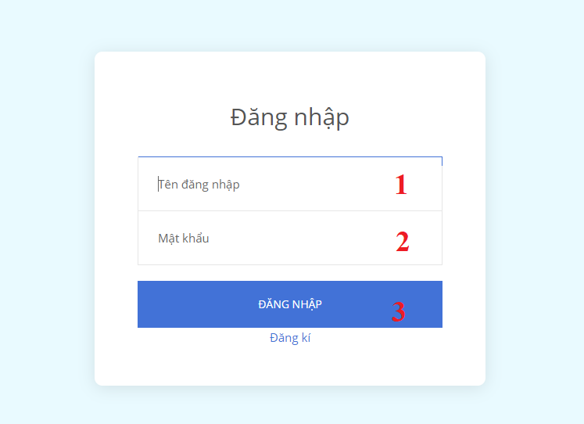

|  |  |
| --- | --- |
| **Step** | **Description** |
| 1 | Enter username |
| 2 | Enter password |
| 3 | Click “Đăng nhập” to login |

#### Finish booking

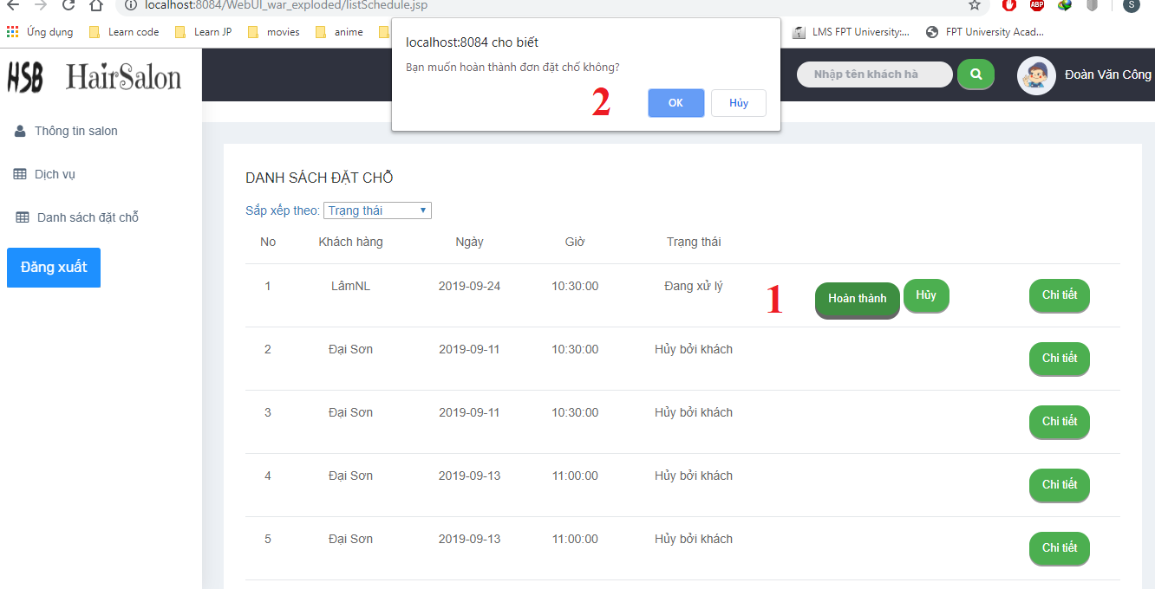

|  |  |
| --- | --- |
| **Step** | **Description** |
| 1 | Click “Hoàn thành” |
| 2 | Click “OK” |

#### Cancel booking



|  |  |
| --- | --- |
| **Step** | **Description** |
| 1 | Click “Hủy” |
| 2 | Click “OK” |

#### Update Salon information

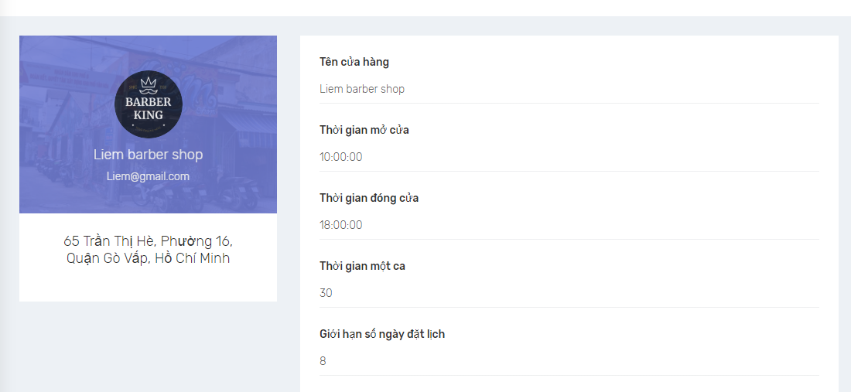

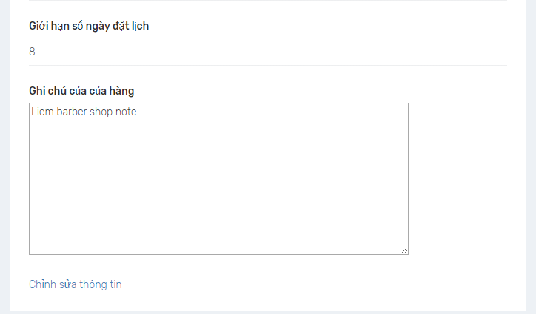

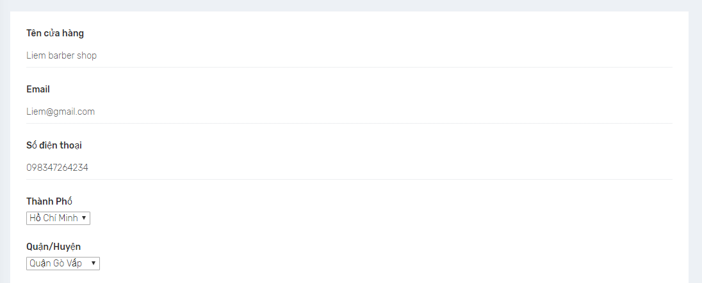

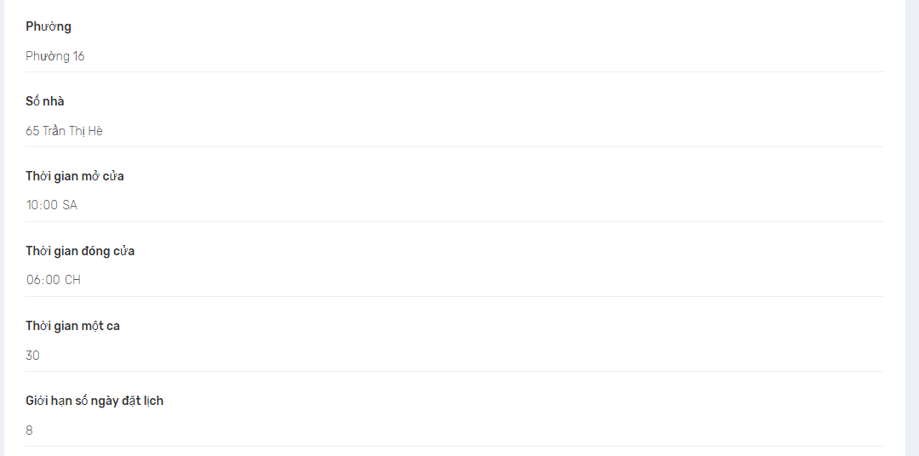

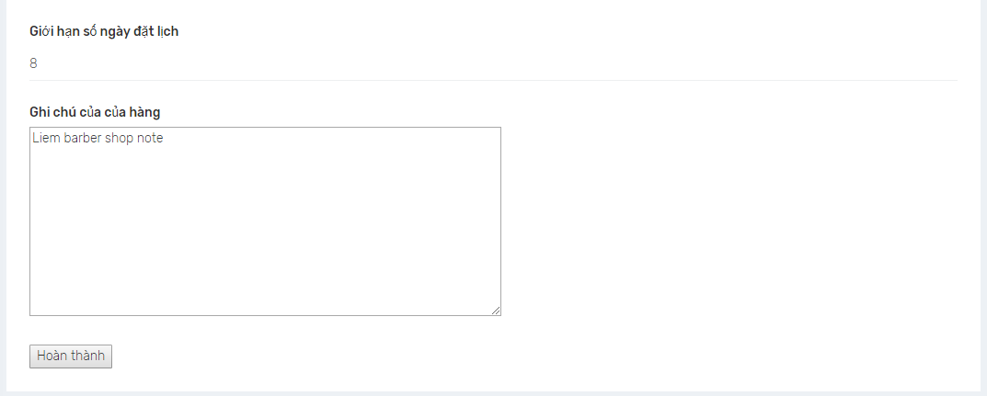

|  |  |
| --- | --- |
| **Step** | **Description** |
| 1 | Click “Chỉnh sửa thông tin” |
| 2 | Enter Salon name |
| 3 | Enter Salon email |
| 4 | Enter Address |
| 5 | Enter Open time |
| 6 | Enter Close time |
| 7 | Enter time of a slot |
| 8 | Enter the range of day |
| 9 | Enter Salon detail |
| 10 | Click “Hoàn Thành” |

#### Create Service

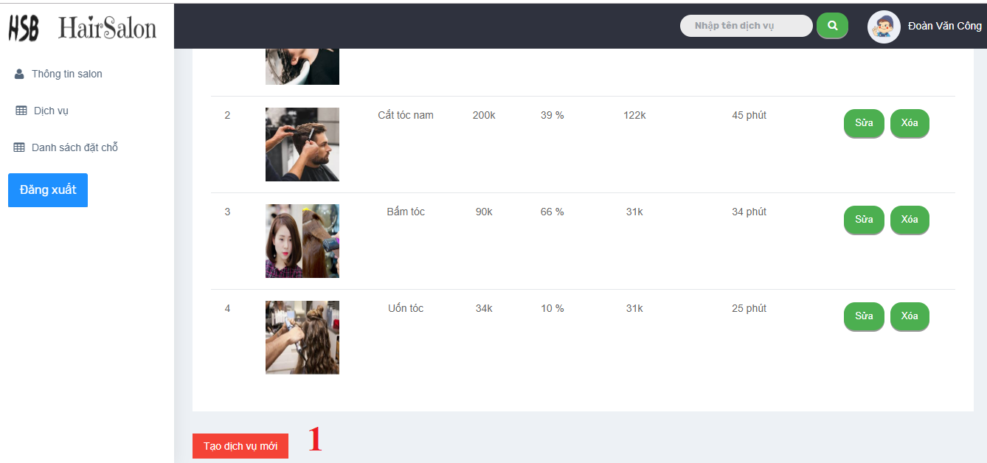

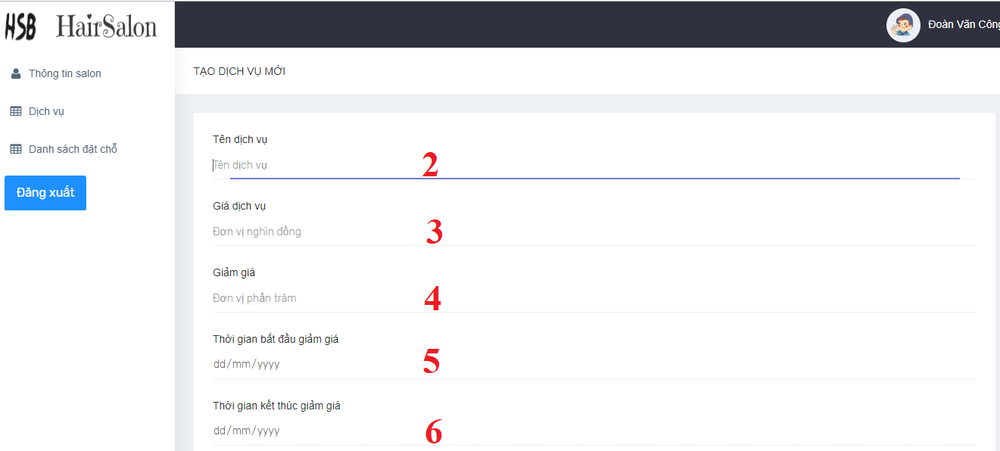

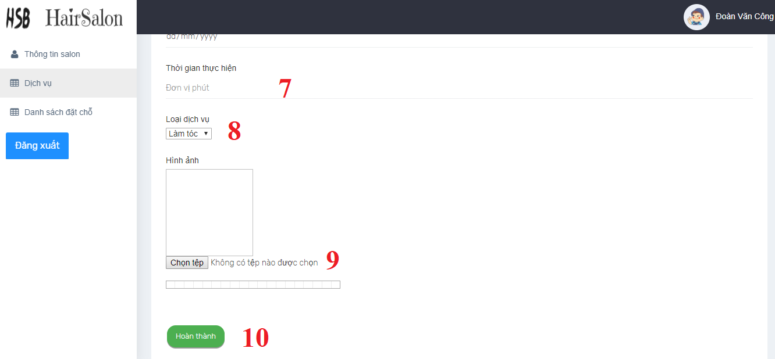

|  |  |
| --- | --- |
| **Step** | **Description** |
| 1 | Click to create new service |
| 2 | Enter Service name |
| 3 | Enter Service price |
| 4 | Enter discout value |
| 5 | Enter discout start time |
| 6 | Enter discout end time |
| 7 | Enter discout end time |
| 8 | Select category |
| 9 | Select image |
| 10 | Click “Hoàn Thành” to create service |

#### Edit service

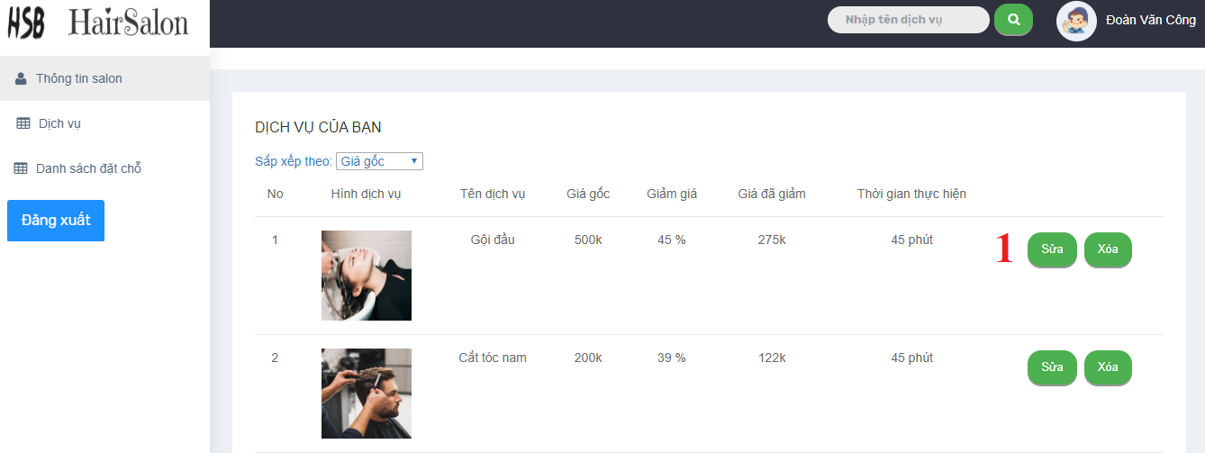

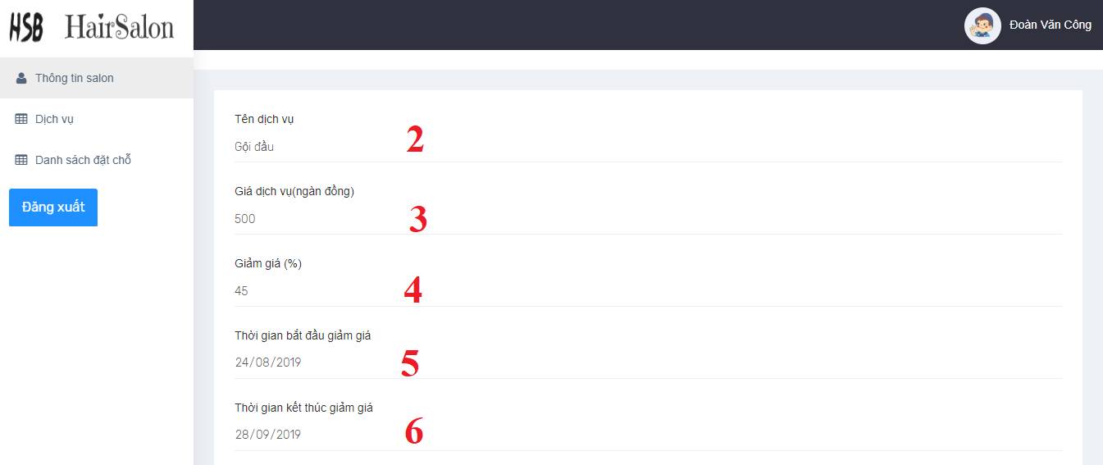

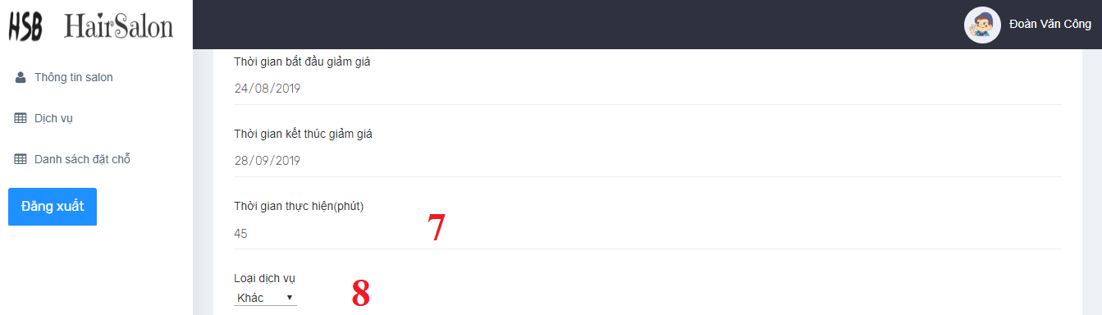

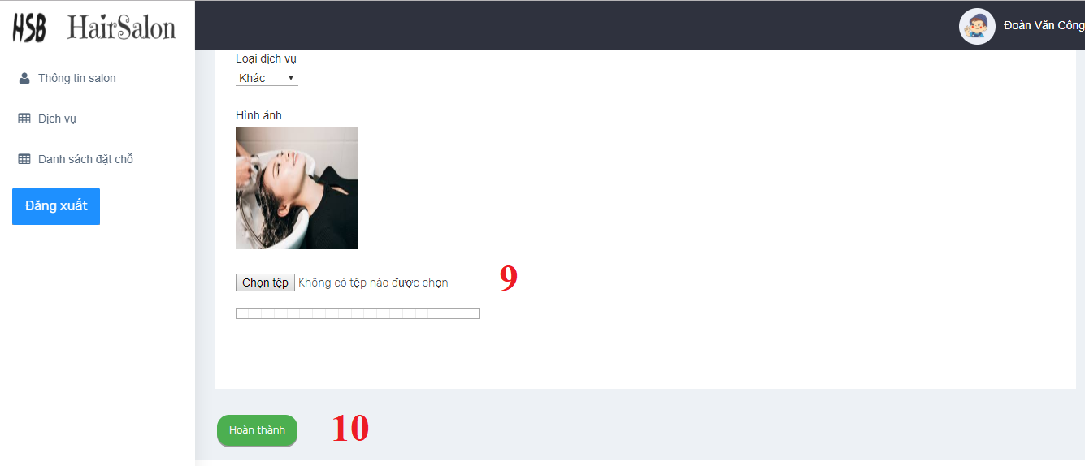

|  |  |
| --- | --- |
| **Step** | **Description** |
| 1 | Click to edit service |
| 2 | Enter Service name |
| 3 | Enter Service price |
| 4 | Enter discout value |
| 5 | Enter discout start time |
| 6 | Enter discout end time |
| 7 | Enter exucute time |
| 8 | Select category |
| 9 | Select image |
| 10 | Click “Hoàn Thành” to update service |

### Mobile application

#### Login

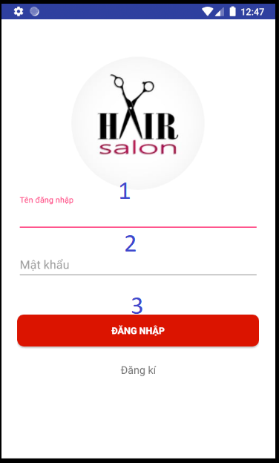

|  |  |
| --- | --- |
| **Step** | **Description** |
| 1 | Enter username |
| 2 | Enter password |
| 3 | Click “Đăng nhập” to login |

#### Register



|  |  |
| --- | --- |
| **Step** | **Description** |
| 1 | Enter name |
| 2 | Enter phone number |
| 3 | Enter email |
| 4 | Enter uername |
| 5 | Enter password |
| 6 | Enter confirm pasaword |
| 7 | Click “Đăng kí” to register |

#### View home screen



|  |  |
| --- | --- |
| **Step** | **Description** |
| 1 | Click hamburger icon to open menu |
| 2 | Enter a keyword to seach service by name |
| 3 | Click location icon to show nearby salon base on current location |
| 4 | Click to view service’s detail and book service |

#### Book services



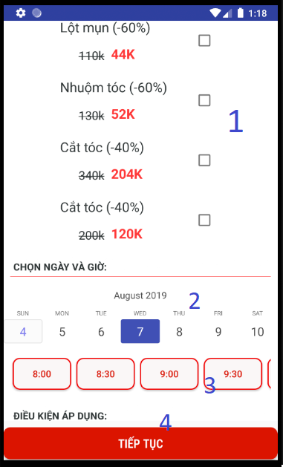

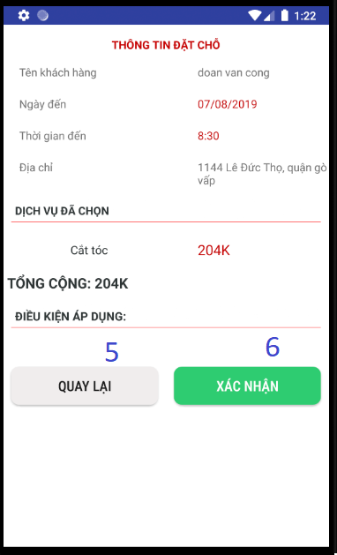

|  |  |  |
| --- | --- | --- |
| **Step** | **Description** | |
| Pre-condition | User must login |
| 1 | Click on check box to choose service | |
| 2 | Click on calendar to choose date |
| 3 | Click on button time to choose time |
| 4 | Click “Tiếp tục” continue booking |
| 5 | Click “ Quay lại” to go back and choose service, date and time again |
| 6 | Click “Xác nhận” to confirm and finish booking |

#### View booking history

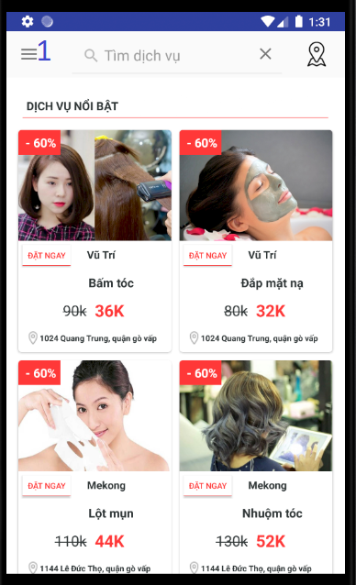

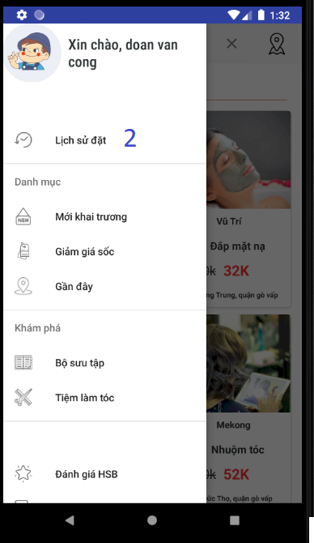



|  |  |
| --- | --- |
| **Step** | **Description** |
| Pre-condition | User must login |
| 1 | Click hambuger icon to open menu |
| 2 | Click “Lịch sử đặt” to view booking history |
| 3 | Click to a result to view booking history detail |

#### Search service by name

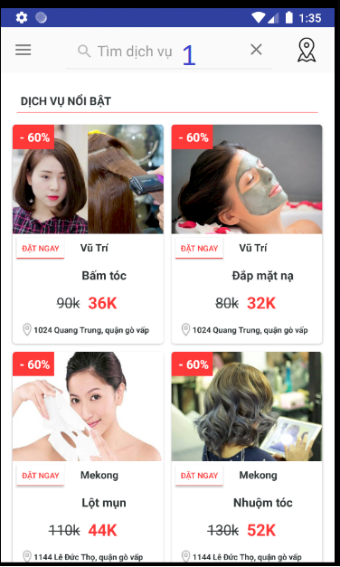



|  |  |
| --- | --- |
| **Step** | **Description** |
| 1 | Enter keyword to search service bay name |
| 2 | Click to a result to view service’s detail and book services |

#### Search salon by location

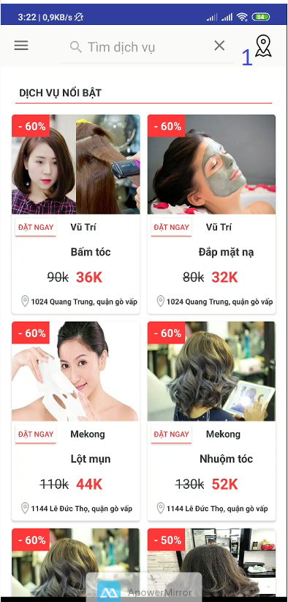

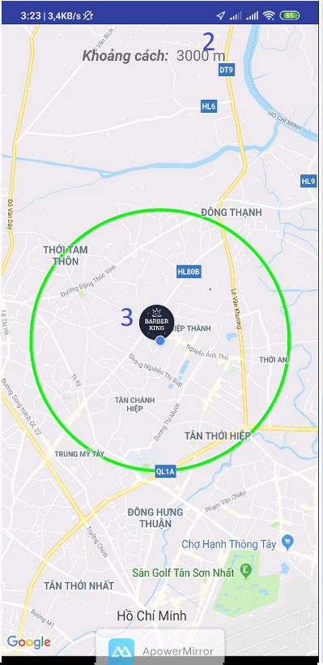



|  |  |
| --- | --- |
| **Step** | **Description** |
| 1 | Click location icon to search nearby salon |
| 2 | Choose the radius (metter) |
| 3 | Click on an icon of salon in map to view salon’s information |
| 4 | Click on salon information to view salon’s detail and book services |

## 取扱説明書

### ウェブシステム

#### ログイン



|  |  |
| --- | --- |
| **Step** | **Description** |
| 1 | ユーザーネームを入力してください |
| 2 | パスワードを入力する |
| 3 | 「Đăngnhập」をクリックしてログインします |

#### 予約を完了

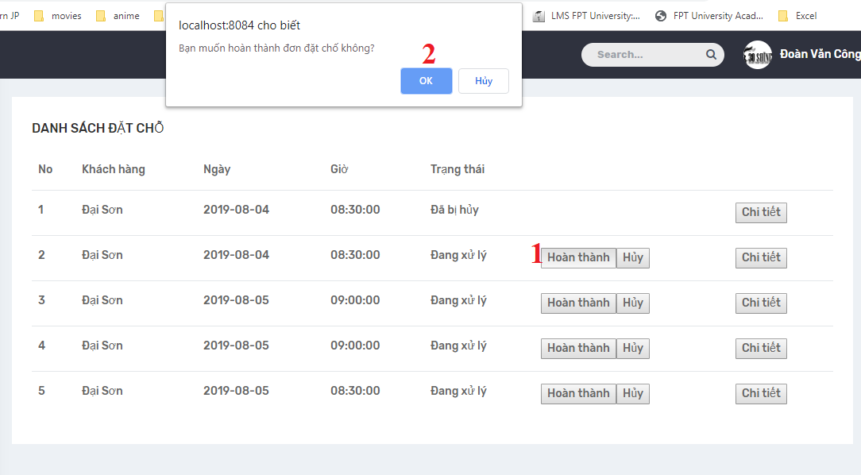

|  |  |
| --- | --- |
| **Step** | **Description** |
| 1 | Hoànthành」をクリックします |
| 2 | 「OK」をクリックします |

#### 予約をキャンセルする

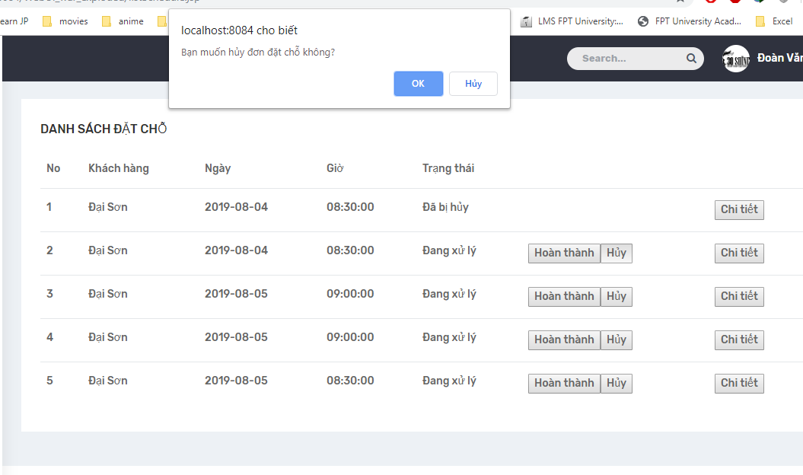

|  |  |
| --- | --- |
| **Step** | **Description** |
| 1 | 「Hủy」をクリックします |
| 2 | 「OK」をクリックします |

#### サロン情報を更新する











|  |  |
| --- | --- |
| **Step** | **Description** |
| 1 | 「Chỉnh sửa thông tin」をクリックします |
| 2 | サロン名を入力してください |
| 3 | サロンのメールアドレスを入力してください |
| 4 | 住所を入力 |
| 5 | 営業時間を入力してください |
| 6 | 閉店時間を入力 |
| 7 | スロットの時間を入力してください |
| 8 | 日の範囲を入力してください |
| 9 | サロンの詳細を入力 |
| 10 | 「HoànThành」をクリックします |

#### サービスを作成する

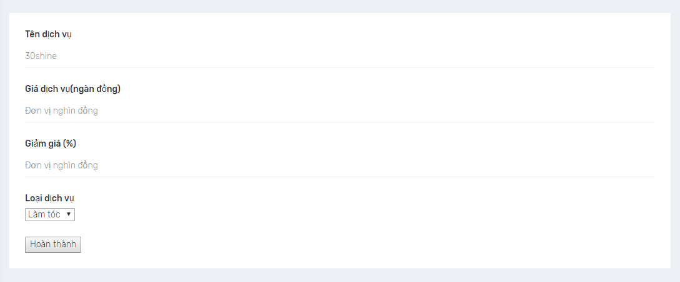

|  |  |
| --- | --- |
| **Step** | **Description** |
| 1 | サービス名を入力してください |
| 2 | サービス価格を入力してください |
| 3 | 割引値を入力してください |
| 4 | カテゴリを選んでください |
| 5 | 「HoànThành」をクリックしてサービスを作成します |

#### サロン情報を更新する











|  |  |
| --- | --- |
| **Step** | **Description** |
| 1 | 「Chỉnh sửa thông tin」をクリックします |
| 2 | サロン名を入力してください |
| 3 | サロンのメールアドレスを入力してください |
| 4 | 住所を入力 |
| 5 | 営業時間を入力してください |
| 6 | 閉店時間を入力 |
| 7 | スロットの時間を入力してください |
| 8 | 日の範囲を入力してください |
| 9 | サロンの詳細を入力 |
| 10 | 「HoànThành」をクリックします |

#### サロン情報を更新する











|  |  |
| --- | --- |
| **Step** | **Description** |
| 1 | 「Chỉnh sửa thông tin」をクリックします |
| 2 | サロン名を入力してください |
| 3 | サロンのメールアドレスを入力してください |
| 4 | 住所を入力 |
| 5 | 営業時間を入力してください |
| 6 | 閉店時間を入力 |
| 7 | スロットの時間を入力してください |
| 8 | 日の範囲を入力してください |
| 9 | サロンの詳細を入力 |
| 10 | 「HoànThành」をクリックします |

### モバイルアプリ

#### ログイン



|  |  |
| --- | --- |
| **Step** | **Description** |
| 1 | ユーザーネームを入力してください |
| 2 | パスワードを入力する |
| 3 | 「Đăng nhập」をクリックしてログインします |

#### 登録



|  |  |
| --- | --- |
| **Step** | **Description** |
| 1 | 名前を入力 |
| 2 | 電話番号を入力してください |
| 3 | メールアドレスを入力して |
| 4 | ユーザーネームを入力してください |

#### ホーム画面を表示



|  |  |
| --- | --- |
| **Step** | **Description** |
| 1 | ハンバーガーアイコンをクリックしてメニューを開きます |
| 2 | 名前でサービスを検索するキーワードを入力してください |
| 3 | ロケーションアイコンをクリックして、現在のロケーションの近くのサロンベースを表示します |

#### 予約サービス







|  |  |  |
| --- | --- | --- |
| **Step** | **Description** | |
| 前提条件 | ユーザーはログインする必要があります |
| 1 | チェックボックスをクリックしてサービスを選択します | |
| 2 | カレンダーをクリックして日付を選択します |
| 3 | ボタンの時間をクリックして時間を選択します |
| 4 | 「Tiếp tục」をクリックして予約を続ける |
| 5 | 「Quay lại」をクリックして戻って、サービス、日付と時刻を再度選択します |

#### 予約履歴を見る







|  |  |
| --- | --- |
| **Step** | **Description** |
| 前提条件 | ユーザーはログインする必要があります |
| 1 | ハンバーガーアイコンをクリックしてメニューを開きます |
| 2 | 「Lịch sử đặt」をクリックして予約履歴を表示します |
| 3 | Click to a result to view booking history detail |

#### 名前で検索サービス





|  |  |
| --- | --- |
| **Step** | **Description** |
| 1 | 名前で検索サービスにキーワードを入力してください |
| 2 | 結果をクリックして、サービスの詳細を表示し、サービスを予約します |

#### サロンを場所で検索







|  |  |
| --- | --- |
| **Step** | **Description** |
| 1 | ロケーションアイコンをクリックして、近くのサロンを検索します |
| 2 | 半径（メートル）を選択します |
| 3 | 地図のサロンのアイコンをクリックして、サロンの情報を表示します |
| 4 | サロン情報をクリックして、サロンの詳細を表示し、サービスを予約します |







|  |  |
| --- | --- |
| **Step** | **Description** |
| 前提条件 | ユーザーはログインする必要があります |
| 1 | ハンバーガーアイコンをクリックしてメニューを開きます |
| 2 | 「Lịch sử đặt」をクリックして予約履歴を表示します |
| 3 | Click to a result to view booking history detail |

#### 予約履歴を見る







|  |  |
| --- | --- |
| **Step** | **Description** |
| 前提条件 | ユーザーはログインする必要があります |
| 1 | ハンバーガーアイコンをクリックしてメニューを開きます |
| 2 | 「Lịch sử đặt」をクリックして予約履歴を表示します |
| 3 | Click to a result to view booking history detail |







|  |  |
| --- | --- |
| **Step** | **Description** |
| 前提条件 | ユーザーはログインする必要があります |
| 1 | ハンバーガーアイコンをクリックしてメニューを開きます |
| 2 | 「Lịch sử đặt」をクリックして予約履歴を表示します |
| 3 | Click to a result to view booking history detail |

# Appendix

1. **Spring Framework** *[Online]* Available: https:/spring.io/docs/reference.
2. **SQL Server** *[Online]* Available: <https://www.microsoft.com/en-us/sql-server/sql-server-downloads>.
3. **JavaScript** *[Online]* Available: <https://developer.mozilla.org/vi/docs/Web/JavaScript>
4. **IntelliJ IDEA** *[Online]* Available: <https://www.jetbrains.com/idea/documentation/>
5. **Android Studio** *[Online]* Available: <https://developer.android.com/docs>